**A PROJECT REPORT**

### MAA BHARTI PG COLLEGE

**UNIVERSITY OF KOTA**

**DEPARTMENT - BACHELOR OF COMPUTER APPLICATIONS**

 QUIZ APPLICATION

AN INITIATIVE WAY TO GAIN KNOWLEDGE AND TEST YOUR PROGRESS

**ABSTRACT -The Quiz Application Is An User-Friendly Platform**

**Designed to Enhance Learning. Developed Using Python (Tkinter) And SQL. It Features a Dynamic UI, Multiple Question Categories. The**

**System Ensures, Multi-Window Navigation, And Efficient Database Management to Deliver an Engaging Quiz Experience**

**CREATED BY:**

**YASHIKA SORANI**

**MANISH RANA**

**ARVINND SINGH.**

**DEVENDRA JHANGID**

**ALI RAZA**

**SUBMITTED TO - DR KUSHAL NAGAR SUBMITED ON - 15 MAY**

**(PROJECT GUIDE) 2025**

**Table of Contents**

1. **Certificate**
2. **Acknowledgement**
3. **Preface**
4. **About Project**
5. **About Visual Basic**
6. **System Development Life Cycle**
7. **Database Design**
8. **Coding**
9. **Snapshots**
10. **Conclusion**

**Certificate**

**This is to certify that Mrs. Yashika Sorani, Mr. Manish Rana, Mr. Devendra Janghid, Mr. Arvind Singh, Mr. Ali raza from MAA BHARTI P.G. COLLEGE have completed**

**their Project training titled QUIZ APPLICATIONS**

**Using Python Tkinter dated from**

**[15/12/24] to [15/1/25] as a student of**

**BCA Second year (3rd semester), student of Kota University.**

**_______________________**

## Signature of Guide / Supervisor

**Name: __ ___ External**

**Place: ____Kota____**

**Acknowledgement**

**It’s our pleasure to be indebted to various people, who directly**

**or indirectly contributed in the development of this work and**

**who influenced our thinking, behavior, and acts during the**

**course of study.**

**We are thankful to Mr. Mahaveer Khushwaha for his support, cooperation, and motivation provided to us during the training**

**for constant inspiration, presence and blessings.**

**We also extend our sincere appreciation to Mrs*.* Vinita Sharma**

**and Mrs. Sarita Gautamwho provided their valuable suggestions and precious time in accomplishing our training report.**

**Lastly, we would like to thank the almighty and our parents for their moral support and our friends with whom. We share our**

**day-to-day experience and received lots of suggestions that improved our quality**

**of work.**

***Yashika Sorani***

***Manish Rana***

***Devendra Janghid***

***Arvind Singh***

***Ali raza***

**Preface**

**This project is developed to computerization and a study of**

**“Quiz application ”.**

**In our study, divide it in seven chapters. Chapter-1 Indicate the meaning of the project; Chapter-2 About Python Tkinter library in which we prepared our project, Chapter-3 About System Development Life Cycle, Chapter-4 About ER Diagram,**

**Chapter-5 About Database Design, Chapter-6 Coding, Chaper-7 Snapshots .**

**Our thanks are also due to other faculties and lab supervisors. We are greatly thankful to the Director of the MAA BHARTI P.G. COLLEGE, Mahaveer Nagar III, Kota, Mr. DINESH VIJAY for their timely, Prompt aid in providing and making available to us the relevant literature of end for this study**.

**We would also like to thank God for the ability he has given us to do such a task.**

**With thanks to all**

***Yashika Sorani***

***Manish Rana***

***Devendra Janghid***

***Arvind Singh***

***Ali raza***

**B.C.A. Second year (3rd semester)**

**About Project**

***QUIZ APPLICATION***

* **Introduction**

This report presents a comprehensive overview of the Quiz Application, detailing its functionality, features, and user engagement process. The application is designed to provide an interactive learning experience through quizzes, educational resources, and performance tracking. Objective of the Application.

* To create an intuitive platform for knowledge assessment.
* To offer learning materials for users to study before
* attempting quizzes.
* To maintain a competitive leaderboard for performance tracking.
* To provide a seamless authentication and feedback system
* for user interaction.
* **Basic Structure of the Application**

The Quiz Application consists of multiple screens and menus that facilitate user interaction and engagement. Below is the hierarchical structure of the application with formal modifications.

* **Welcome Screen**

Displays the application's name, logo, and introduction.

Provides options for user authentication:

1. Register – New users create an account.
2. Login – Existing users access their profile.

* **Choose Your Way (Main Menu Screen)**

Once logged in, users are directed to the Main Menu, where they can select their desired action. The menu includes six interactive tabs and buttons:

1. Q&A – Allows users to attempt individual questions directly.
2. About Us – Displays detailed information about the application, its purpose, and development.
3. Learn – Provides study materials for users to read notes before attempting quizzes.
4. Topics – Users select a quiz topic from four available categories.
5. Leaderboard – Displays rankings, scores, and competitive performance insights.
6. Feedback – Users submit reviews, ratings, and suggestions for improvements.

* **Learn Section**

Allows users to explore four subjects for studying.

Users can access notes and reference materials to strengthen their understanding before attempting quizzes.

Topics Section (Quiz Selection)

Users can choose from four topics to learn from quiz.

* **Quiz Session**

There are 3 types of quiz:

1. MULTIPLE COISE QUESTION
2. FILL IN THE BLENKS
3. TRUE / FALSE

The quiz follows a structured **five-level system**, ensuring progressive difficulty. Each level consists of approximately **5 - 10 questions** on

4 topics and **3 quiz type**. Users must achieve a minimum score **of 30 - 50 marks** to level up. Failure to reach **30 - 50 marks** require a re-attempt before proceeding. Scores are automatically recorded in the **Leaderboard** upon completion.

**Quiz (Attempting the Quiz):**

1. Questions & Answer Choices – Users select the correct answer from multiple options.
2. Level Progression – Advancement depends on meeting the minimum score requirement.
3. Different types of Quiz – User can choose between three different quiz types
4. Leaderboard Integration – Scores are saved and visible for performance tracking.
5. Time Constraints (if applicable) – Some quizzes may have a time limit for added challenge.
6. Quit Button –Users may quit the quiz anytime if they wish to leave the session.

* **Leaderboard Section**

The Leaderboard displays the score in a ranked format:

1. RANK
2. NAME
3. SUBJECT
4. QUIZ TYPE
5. LEVEL

Users can view their performance and scores compared to others.

Provides an option to go back to the previous screen for smooth navigation.

* **Feedback Section**

Enables users to provide, reviews, and suggestions for improvement. It has two buttons:

1. Submit
2. Back

**About Python, MySQL and Tkinter**

INTRODUCTION TO PYTHON

## Introduction to Python:

Python is a popular programming language. It was created by Guido van Rossum, and released in 1991.

It is used for:

* Web development (server-side),
* Software development,
* Mathematics,
* System scripting.

## Features of Python:

1. **Simple**

Python is a simple and minimalistic language. Reading a good Python program feels almost like reading English language.

## Easy to learn

Python uses very few keywords. Python has an extraordinarily simple syntax and simple program structure.

## Open Source

There is no need to pay for Python software. Python is FLOSS (Free/Library and Open-Source Software). Its source can be read, modified and used in programs as desired by the programmers.

## High level language

When you write programs in Python, you never need to bother about the low- level details such as managing the memory used by your program, etc.

## Dynamically typed.

Python provides IntelliSense. IntelliSense to make writing your code easier and more error-free. IntelliSense option includes statement completion, which provides quick access to valid member function or variables, including global, via the member list. Selecting from the list inserts the member into your code.

## Portable

Due to its open-source nature, Python has been ported to (i.e. changed to make it work on) many platforms. All your Python programs can work on any of these platforms without requiring any changes at all if you are careful enough to avoid any system-dependent features.

## Platform independent

When a Python program is compiled using a Python compiler, it generates byte code. Python’s byte code represents a fixed set of instructions that run on all operating systems and hardware. Using a Python Virtual Machine (PVM), anybody can run these byte code instructions on any computer system. Hence, Python programs are not dependent on any specific operating system.

## Procedure and Object Oriented

Python supports procedure-oriented programming as well as object-oriented programming. In procedure-oriented languages, the program is built around procedures or functions which are nothing but reusable pieces of programs. In object- oriented languages, the program is built around objects which combine data and functionality.

**DATA TYPES IN PYTHON**

A data type represents the type of data stored into a variable or memory. There are 5 different data types:

* None type.
* Numeric type
* Sequences
* Sets
* Dictionary

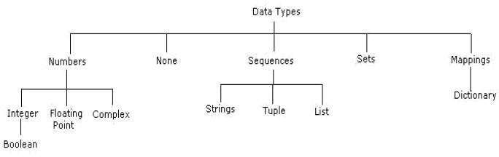

**None data type:** The none data type represents an object that does not contain any value. In java language it is called “NULL” object. But in Python it is called as “none”. In Python a maximum of only one ‘none ‘object is provided. If no value is passed to the function, then the default value will be taken as ‘none’.

## Numeric data type

The numeric type represents numbers. There are 3 subtypes:

* int
* float
* complex

## Int data type

The int data type represents integer number (Whole number). An integer number is number without fraction. Integers can be of any length, itis only limited by the memory available.

**E.**g. a=10 b=-29

## Float data type

The float data type represents floating point number. A floating point number is a number with fraction. Floating point numbers can also be written in scientific notation using exponentiation format.

A floating-point number is accurate up to 15 decimal places. Integer and floating points are separated by decimal points.

## Complex data type:

A complex number is number is written in the form of x +yj or x+yJ. Here x is the real part, and y is the imaginary part.

We can use the **type ()** function to know which class a variable or a value belongs to and the **isinstance()** function to check if an object belongs to a particular class.

E.g.

a = 5

print (a, "is of type", type(a)) b = 2.0 print (a, "is of type", type(b))

# SEQUENCES

A sequence represents a group of items or elements. There are six types of sequences in Python. Important sequences as follows,

* **str**
* **list**
* **tuple**

**str data type:** The str represents string data type. A string is a collection of character enclosed in single or double quotes. Both are valid.

E.g. str=” kvn” # str is name of string variable

str=’vedish’ # str is name of string variable

Triple double quotes or triple single quotes are used to embed a string in another string (Nested string).

str=”””This is ‘str data type’ example”””

print(str)# output is :

This is ‘str data type’

Example

The [] operator used to retrieve specified characters from the string. The string index starts from 0. Hence, str [0] indicates the 0th character in the string.

e.g. str=” SSCASC Tumkur”

print(str)# it display - SSCASC Tumkur

print (str [0])# it display - G

## list data type

A List is a collection which is ordered and changeable. It allows duplicate members. A list is similar to array. Lists are represented by square brackets [] and the elements are separated by comma.

The main difference between a list and an array is that a list can store different data type elements, but an array can store only one type ofelements. List can grow dynamically in memory but the size of array is fixed and they cannot grow dynamically.

e.g. list=[10,3.5,-20, “SS”,’kumar’] # create a list print(list)#it display all elements in the list

output- :

10,3.5,-20,“SS”,’kumar’

## Tuple data type

A tuple is similar to list. A tuple contains group of elements which can be different types. The elements in the tuple are separated by commas and enclosed in parentheses (). The only difference is that tuples are immutable. Tuples once created cannot bemodified. The tuple cannot change dynamically. That means a tuple can be treated as read-only list.

e.g. tpl=(10,3.5,-20, “Amit”,’Kumar’) # create a tuple print(tpl) #it display all elements in the tuple :

output-

10,3.5,-20,“Amit”,’kumar’

## Sets

Set is an unordered collection of unique items and un-indexed. The order of elements is not maintained in the sets. A set does not accept duplicate elements. Set is defined by values separated by comma inside braces { }.

## There are two sub types in sets:

* Set data type
* Frozen Set data type

**Set data type:** To create a set, we should enter the elements separated bycomma inside a curly brace.

* 1. s = {10,30, 5, 30,50}

print(s)# it display : {10,5,30,50}

In the above example, it displays un-orderly and repeated elements only once, because set is unordered collection and unique items.

We can use set() to create a set asK=set(“kvn”) Print(K) # it display : “kvn”

## Frozen set data type

Frozen set is just an immutable version of a Python set object. While elements of a set can be modified at any time, an element of frozen set remains the same after creation. Due to this, frozen sets can be used as key in Dictionary or as element of another set.

**Dictionary:** A dictionary is an unordered collection, changeable and indexed. In Python dictionaries are written with curly brackets, and theyhave keys and values. String operations:

# OPERATORS

* Operators are special symbols which represents computation. They are applied on operand(s), which can be values or variables.
* Same operator can behave differently on different data types. Operators when applied on operands form an expression.
* Operators are categorized as Arithmetic, Relational, Logical and Assignment. Value and variables when used with operator are known as operands.
  + 1. **Arithmetic Operators:**

|  |  |  |  |
| --- | --- | --- | --- |
| **Symbol** | **Description** | **Example-1** | **Example-2** |
| + | Addition | >>> 5 + 6  11 | >>>’SSCASCT’+’B CA’  SSCASCTBCA |
| - | Subtraction | >>>10-5  5 | >>>5 – 6  -1 |
| * | Multiplication | >>> 5*630 | >>>’SSCASCT’ * 2  SSCASCTSSCASCT |
| / | Division | >>> 10 / 5  2 | >>>5 /2.0  2.5 |
| % | Remainder / Modulo | >>> 5 % 2  1 | >>>15%5  0 |
| ** | Exponentiation | >>> 2**38 | >>>2**8256 |
| // | Integer Division | >>> 7.0 // 2  3.0 | >>>3//21 |

* + 1. **Relational Operators:**

|  |  |  |  |
| --- | --- | --- | --- |
| **Symbol** | **Description** | **Example-1** | **Example-2** |
| < | Less than | >>> 7<10  True | >>> ‘SSCASCT’  <’BCA’  False |
| > | Greater Than | >>> 7 >10  False | >>>’SSCASCT’ >  ‘BCA’  True |
| <= | Less than or equal to | >>> 7<=10  True | >>>’SSCASCT’  <=’BCA’  False |
| >= | Greater than or equal to | >>> 7>=10  False | >>>’SSCASCT’>=’BC A’  True |
| != , <> | Not equal to | >>> 7!=10  True | >>>’SSCASCT’!=  ‘sscasct’  True |
| == | Equal to | >>> 7==10  False | >>>’SSCASC’  ==’SSCASC’  True |

**Logical Operators:**

|  |  |  |
| --- | --- | --- |
| **Symbol** | **Description** | **Example-2** |
| or | If any one of the operand is true, then condition becomes TRUE | >>> 7<=10 or 7 ==10  True |
| and | If both the operands are true, then the condition becomes TRUE | >>>7<10 and 7 >20  False |

|  |  |  |
| --- | --- | --- |
| not | Reverse the state of operand / condition | >>> not 7<10False |

* + 1. **Assignment Operator:**

|  |  |  |
| --- | --- | --- |
| **Symbol** | **Description** | **Example-1** |
| = | Assigned values from right side operands  to left variable. the left operand | >>> x=10 10 |

**Bitwise Operator:** a bit is the smallest unit of data storage and it can have only one of the two values, 0 and 1. Bitwise operators works on bits and perform bit- by-bit operation.

|  |  |  |
| --- | --- | --- |
| **Symbol** | **Description** | **Example** |
| | | Performs binary OR operation | 5 | 3 gives 7 |
| & | Performs binary AND operation | 5 & 3 gives 1 |
| ~ | Performs binary XOR operation | 5 ^ 3 gives 6 |
| ^ | Performs binary one's complement operation | ~5 gives -6 |
| << | **Left shift operator**: The left-hand side operand bit is  moved left by the number specified on the right-handside (Multiply by 2) | 0010 << 2 gives 8 |
| >> | **Left shift operator**: The left-hand side operand bit ismoved left by the number  specified on the right-hand side (Divided by 2) | 100 << 2 gives 1 |

Membership operators

Python has membership operators, which test for membership in a sequence, such as strings, lists or tuples. There are two membership operators:

|  |  |  |
| --- | --- | --- |
| **Symbol** | **Description** | **Example** |
| in | Returns True if the specified operand is found in the sequence | >>> x = [1,2,4,6,8]  >>> 3 in xfalse |
| Not in | Returns True if the specified operand is found in the sequence | >>> x = [1,2,4,6,8]  >>> 3 not in xtrue |

**1. Identity operator:** Identity operators compare the memory locations of two objects. There are two Identity operators are:

|  |  |  |  |
| --- | --- | --- | --- |
| **Symbol** | **Description** | **Example** | **Example** |
| is | Returns True if two variables point to the same object and False, otherwise | >>>X=10  >>>Y=10  >>> X is Y  true | >>> x=[1,2,3]  >>> y=[1,2,3]  >>> x is yfalse |
| is not | Returns False if two variables point to thesame object and True, otherwise | >>>X=10  >>>Y=10  >>> X is not Yfalse | >>> x=[1,2,3]  >>> y=[1,2,3]  >>> x is not y true |

**CONTROL STATEMENTS**

## If Statements

One-way if statement executes the statements if the condition is true. The syntax fora one-way if statement is:

if Boolean-expression:

## Statement # Note that the statement(s) must be indented

* The reserved word if begins a if statement.
* The condition is a Boolean expression that determines whether or not the body will be executed. A colon (:) must follow the condition.
* The block is a block of one or more statements to be executed if the condition is true.

The statements within the block must all be indented the same number of spaces from the left. The block within an Example: To demonstrate simple if

#Get two integers from the user

Dividend = int(input('Please enter the number to divide: '))

Divisor = int(input('Please enter dividend: ')) # If possible, divide them and report the result if divisor != 0:

Quotient = dividend/divisor

Print(dividend, '/', divisor, "=", quotient)print('Program finished') Output

Please enter the number to divide: 4Please enter dividend: 5 4 / 5 = 0.8

Program finished

## If-else statements

A two-way **if-else** statement decides which statements to execute based on whether the condition is true or false.

The syntax for a two-way **if-else** statement:

if Boolean-expression:

Statement(s) #for-the-true-case ,the statement(s) must be indented Else: statement(s) #for-the-false-case

Example: to demonstrate if else Percent=float(input("enter percentage"))if percent >= 90.0:

Print ("congratulations, you got an a") print ("you are doing well in this class") Else:

Print ("you did not get an a")

Print ("see you in class next week")

## Nested if statements.

A series of tests can written using nested if statements.

**Example: Nested if** percent=float(input("Enter Percentage")) if (percent >= 90.00):

Print ('congratulations, you got an A')else:

If (percent >= 80.0): print ('you got a B') Else:

If (percent >= 70.0): print ('you got a C') Else:

Print ('your grade is less than a C')

## If_elif_else Statement

In Python we can define a series of conditionals (multiple alternatives) using if for the first one, elif for the rest, up until the final (optional) else for anything not caught by the other conditionals.

**Example:If_elif_else** score=int(input("Enter Score"))if score >= 90.0: grade = 'A' elif score >= 80.0:

grade = 'B' elif score >= 70.0:

grade = 'C' elif score >= 60.0:

grade = 'D'else:

grade = 'F' print("Grade=",grade)

Using **else if** instead of **elif** will trigger a syntax error and is not allowed.

## Loops

It is one of the most basic functions in programming; loops are important in every programming language. Loops enable is to execute a statement repeatedly which are referred to as iterations. (A loop is used to tell a program to execute statements repeatedly).

The simplest type of loop is a **while** loop. The syntax for the while loop is:

**while** loop-continuation-condition:# Loop body Statement(s)# Note that the statement(s) must be indented

i = initialValue # Initialize loop-control variable

**while** i <

endValue:# Loop body

Example1: To demonstrate while count = 0#Program to print “Programming

is fun!” for 10 times

**while** count < 10: print("Programming is fun!")count = count + 1

## The for Loop

A for loop iterates through each statement in a sequence for exactly know many times the loop body needs to be executed, so a control variable can be used to count the executions. A loop of this type is called a counter-controlled loop. In general, the loop can be written.

as follows:

**for** i in range(initialValue, endValue):

# Loop body #Note that the statement(s) must be indented In general, the syntax of a for loop is:

**for** var in sequence:# Loop body

The function **range(a, b)** returns the sequence of integers **a**, **a + 1**, ..., **b-2**, and **b- 1.** The **range** function has two more versions. You can also use **range(a)** or **range(a, b,k)**. **range(a)** is the same as **range(0, a). k** is used as **step value** in **range(a, b, k)**. The first number in the sequence is **a**. Each successive number in the sequence will increase by the step value **k**. **b** is the limit. The last number in the sequence must be less than **b**.

**Break and Continue in Loops break** statement:

When a break statement executes inside a loop, control flow comes out of the loop immediately:

Example: to demonstrate **break**

i = 0

**while** i < 7:

print(i)

if i == 4:

print("Breaking from loop") break

i += 1

The loop conditional will not be evaluated after the break statement is executed. Note that break statements are only allowed inside loops. A break statement inside a function cannot be used to terminate loops that called that function.

Executing the following prints every digit until number 4 when the break statement is met and the loop stops:

Output 01234

## Breaking from loop

Break statements can also be used inside for loops, the other looping construct provided by Python:

Example:

**for** i in (0, 1, 2, 3, 4):

print(i)

if i == 2:

break

Executing this loop now prints:

012

Note that 3 and 4 are not printed since the loop has ended.

## Continue statement

A continue statement will skip to the next iteration of the loop bypassing the rest of the current block but continuing the loop. Continue can only used inside loops:

Example to demonstrate continue

**for** i in (0, 1, 2, 3, 4, 5):if i == 2 or i == 4:

continue print(i)

Note that 2 and 4 aren't printed, this is because continue goes to the next iteration instead of continuing on to print(i) when i == 2 or i

== 4.

**Slicing String**

Python slicing is about obtaining a sub-string from the given string by slicing it respectively from start to end.

## How String slicing in Python works

For **understanding slicing** we will use different methods, here we will cover 2 methods of string slicing, the one is using the in-build slice() method and another using the **[:] array slice**. String slicing in Python is about obtaining a sub-string from the given [string](https://www.geeksforgeeks.org/python-strings/) by slicing it respectively from start to end.

## Python slicing can be done in two ways:

* Using a slice() method
* Using array slicing [ : : ] method

## Index tracker for positive and negative index

String indexing and slicing in python. Here, the Negative comes into consideration when tracking the string in reverse.

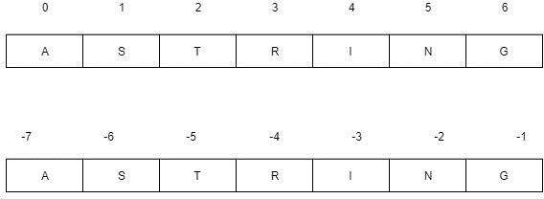

## Method 1: Using slice() method

The [slice()](https://www.geeksforgeeks.org/python-slice-function/) constructor creates a slice object representing the set of indices specified by range(start, stop, step)

Syntax:

* slice(stop)
* slice(start, stop, step)

**Parameters: start:** Starting index where the slicing of object starts. **stop:** Ending index where the slicing of object stops. **step:** It is an optional argument that determines the increment between each index for slicing. **Return Type:** Returns a sliced object containing elements in the given range only.

## Example:

# Python program to demonstrate # string slicing

# String slicing String = 'ASTRING'

# Using slice constructor s1 = slice(3)

s2 = slice(1, 5, 2)

s3 = slice(-1, -12, -2)

print(& quot String slicing & quot ) print(String[s1])

print(String[s2]) print(String[s3])

**Output:** String slicing AST

SR GITA

## Python String Functions

The Python String Functions which we are going to discuss in this article are as follows:

* Capitalize( ) function
* Lower( ) function
* Title( ) function
* Casefold( ) function
* Upper( ) function
* Count( ) function
* Find( ) function
* Replace( ) function
* Swapcase( ) function
* Join( ) function

# FUNCTIONS

* A function is a collection of statements grouped together that performs an operation.
* A function is a way of packaging a group of statements for later execution.

The function is given a name. The name then becomes a short- hand to describe the process. Once defined, the user can use it by the name, and not by the steps involved. Once again, we have separated the “what” from the“how”, i.e. abstraction.

Functions in any programming language can fall into two broad categories:

* Built-in functions

They are predefined and customized, by programming languages and each serves aspecific purpose.

* User-defined functions

They are defined by users as per their programming requirement.

## There are two sides to every Python function:

**Function definition**. The definition of a function contains the code that determines the function’s behaviors.

**Function call**. A function is used within a program via a function invocation.

## Defining a Function

A function definition consists of the function’s name, parameters, and body.

The syntax for defining a function is as follows:

**def** function Name(list of parameters):

Statements # Note that the statement(s) must be indented return

* A function contains a header and body. The header begins with the def keyword, followed by the function’s name known as the identifier of the function and parameters, and ends with a colon.
* The variables in the function header are known as formal parameters or simply parameters. When a function is invoked, you pass a value to the parameter. This value is referred to as an actual parameter or argument. Parameters are optional; that is, a function may not have any parameters.
* Statement(s) – also known as the function body – are a nonempty sequence of statements executed each time the function is called. This means a function body cannot be empty, just like any indented block.
* Some functions return a value, while other functions perform desired operations without returning a value. If a function returns a value, it is called a value- returning function.

## Calling a Function

Calling a function executes the code in the function. In a function’s definition, you define what it is to do. To use a function, you have to call or invoke it. The programthat calls the function is called a caller. There are two ways to call a function, depending on whether or not it returns a value. If the function returns a value, a call to that function is usually treated as a value.

For example, larger = max(3, 4)

Calls max(3, 4) and assigns the result of the function to the variable larger.

Another example of a call that is treated as a value is print(max(3, 4))

This prints the return value of the function call max (3, 4).

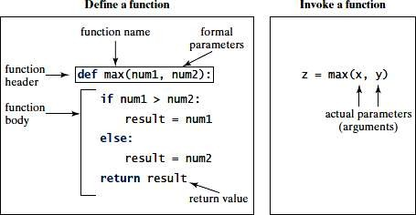

## Python Tuples

A collection of ordered and immutable objects is known as a tuple. Tuples and lists are similar as they both are sequences. Though, tuples and lists are different because we cannot modify tuples, although we can modify lists after creating them, and also because we use parentheses to create tuples while we use square brackets to create lists.

Placing different values separated by commas and enclosed in parentheses forms a tuple. For instance,

## Example

1. tuple_1 = ("Python", "tuples", "immutable", "object")
2. tuple_2 = (23, 42, 12, 53, 64)
3. tuple_3 = "Python", "Tuples", "Ordered", "Collection"

We represent an empty tuple by two parentheses enclosing nothing. Empty tuple = ()

We need to add a comma after the element to create a tuple of a single element Tuple_1 = (50,)

Tuple indices begin at 0, and similar to strings, we can slice them, concatenate them, and perform other operations.

## Creating a Tuple

All the objects (elements) must be enclosed in parenthesis (), each separated by a comma, to form a tuple. Although using parenthesis is not required, it is recommended to do so.

Whatever the number of objects, even of various data types, can be included in a tuple (dictionary, string, float, list, etc.).

* # Python program to show how to create a tuple
* # Creating an empty tuple
* empty_tuple = ()
* print("Empty tuple: ", empty_tuple)
* # Creating tuple having integers
* int_tuple = (4, 6, 8, 10, 12, 14)
* print("Tuple with integers: ", int_tuple)
* # Creating a tuple having objects of different data types
* mixed_tuple = (4, "Python", 9.3)
* print("Tuple with different data types: ", mixed_tuple)
* # Creating a nested tuple
* nested_tuple = ("Python", {4: 5, 6: 2, 8:2}, (5, 3, 5, 6))
* print("A nested tuple: ", nested_tuple)

## Output:

Empty tuple: ()

Tuple with integers: (4, 6, 8, 10, 12, 14)

Tuple with different data types: (4, 'Python', 9.3)

A nested tuple: ('Python', {4: 5, 6: 2, 8: 2}, (5, 3, 5, 6))

Parentheses are not mandated to build tuples. Tuple packing is the term for this.

Tuple Operations

Like string, tuple objects are also a sequence. Hence, the operators used with strings are also available for the tuple.

|  |  |  |
| --- | --- | --- |
| Operator | Example | |
| The **+** operator returns a tuple containing all the | >>> t1=(1,2,3) | |
| elements of the first and the second tuple object. | >>> t2=(4,5,6) | |
|  | >>> t1+t2 | |
|  | (1, 2, 3, 4, 5, 6) | |
|  | >>> t2+(7,) | |
|  | (4, 5, 6, 7) | |
| The **\*** operator Concatenates multiple copies of the same tuple. | >>> t1=(1,2,3) |  |
| >>> t1*4 | |
| (1, 2, 3, 1, 2, 3, | |
| 1, 2, 3, 1, 2, 3) |  |
|  | |
| The **[]** operator Returns the item at the given | >>> | |
| index. A negative index counts the position from | t1=(1,2,3,4,5,6) | |
| the right side. | >>> t1[3] | |
|  | 4 | |
|  | >>> t1[-2] | |
|  | 5 | |

|  |  |  |  |
| --- | --- | --- | --- |
| Operator | Example | | |
| The **[:]** operator returns the items in the range specified by two index operands separated  by the : symbol. If the first operand is omitted, the range starts from zero. If the second  operand is omitted, the range goes up to the end of the tuple. | >>> |  | |
| t1=(1,2,3,4,5,6)  >>> t1[1:3] (2, 3)  >>> t1[3:]  (4, 5, 6)  >>> t1[:3] | | |
| (1, 2, 3) | |  |
|  | | |
| The **in** operator returns true if an item exists in the given tuple. | >>> t1=(1,2,3,4,5,6)  >>> 5 in t1 True  >>> 10 in t1  False | | |
| The **not in** operator returns true if an item does not exist in the given tuple. | >>> |  | |
| t1=(1,2,3,4,5,6)  >>> 4 not in t1 False  >>> 10 not in t1 | | |
| True |  | |
|  | | |

# DICTIONARIES:

A dictionary is a collection which is unordered, changeable and indexed. In python dictionaries are written with curly brackets, and they have keys and values.

* Key-value pairs
* Unordered

We can construct or create dictionary like:

X={1:’A’,2:’B’,3:’c’}

X=dict([(‘a’,3) (‘b’,4)]X=dict(‘A’=1,’B’ =2)

## Example:

>>> dict1 = {"brand":"mrcet","model":"college","year":2004}

>>> dict1

{'brand': 'mrcet', 'model': 'college', 'year': 2004}

## Operations and methods:

Methods that are available with dictionary are tabulated below. Some of them have alreadybeen used in the above examples.

|  |  |
| --- | --- |
| **Method** | **Description** |
| [Clear()](https://www.programiz.com/python-programming/methods/dictionary/clear) | Remove all items form the dictionary. |
| [Copy()](https://www.programiz.com/python-programming/methods/dictionary/copy) | Return a shallow copy of the dictionary. |
| [Fromkeys(seq[, v])](https://www.programiz.com/python-programming/methods/dictionary/fromkeys) | Return a new dictionary with keys from seq and value equal to v (defaults to None). |
| [Get(key[,d])](https://www.programiz.com/python-programming/methods/dictionary/get) | Return the value of key. If key doesnot exit,return d (defaults to None). |

|  |  |
| --- | --- |
| [Items()](https://www.programiz.com/python-programming/methods/dictionary/items) | Return a new view of the dictionary's items(key, value). |
| [Keys()](https://www.programiz.com/python-programming/methods/dictionary/keys) | Return a new view of the dictionary's keys. |
| [Pop(key[,d])](https://www.programiz.com/python-programming/methods/dictionary/pop) | Remove the item with key and return its value or d if key is not found. If d is not provided and key is not found, raises KeyError. |
| [Popitem()](https://www.programiz.com/python-programming/methods/dictionary/popitem) | Remove and return an arbitrary item (key, value). Raises KeyError if the dictionary isempty. |
| [Setdefault(key[,d])](https://www.programiz.com/python-programming/methods/dictionary/setdefault) | If key is in the dictionary, return its value. Ifnot, insert key with a value of d and  return d (defaults to None). |
| [Update([other])](https://www.programiz.com/python-programming/methods/dictionary/update) | Update the dictionary with the key/value pairsfrom other, overwriting existing keys. |
| [Values()](https://www.programiz.com/python-programming/methods/dictionary/values) | Return a new view of the dictionary's values |
| [Copy()](https://www.programiz.com/python-programming/methods/dictionary/copy) | Return a shallow copy of the dictionary. |

# PASSING DICTIONARY TO FUNCTIONS

A dictionary in Python is a collection of data which is unordered and mutable. Unlike numeric indices used by lists, a dictionary uses the key as an index for a specific value. It can be used to store unrelated data types but data that is related as a real-world entity. The keys themselves are employed for using a specific value.

## Passing Dictionary as an argument

In Python, everything is an object, so the dictionary can be passed as an argument to a function like other variables are passed.

## Example:

# Python program to demonstrate # passing dictionary as argument # A function that takes dictionary # as an argument

def func(d):

for key in d:

print("key:", key, "Value:", d[key])

# Driver's code

D = {'a':1, 'b':2, 'c':3}

func(D)

## Output:

key: b Value: 2 key: a Value: 1 key: c Value: 3

## Passing Dictionary as kwargs

“kwargs” stands for keyword arguments. It is used for passing advanced data objects like dictionaries to a function because in such functions one doesn’t have a clue about the number of arguments, hence data passed is be dealt properly by adding “**” to the passing type.

## Example 1:

# Python program to demonstrate # passing dictionary as kwargs def display(**name):

print (name["fname"]+" "+name["mname"]+" "+name["lname"])

def main():

# passing dictionary key-value # pair as arguments display(fname ="John", mname ="F.",

lname ="Kennedy") # Driver's code main()

## Output:

John F. Kennedy

## Errors and Exceptions:

**Python Errors and Built-in Exceptions:** Python (interpreter) raises exceptions when it encounters **errors.** When writing a program, we, more often than not, will encounter errors. Error caused by not following the proper structure (syntax) of the language is called syntax error or parsing error

## Zero Division Error:

Zero Division Error in Python indicates that the second argument used in a division (or modulo) operation was zero**.**

## Overflow Error:

Overflow Error in Python indicates that an arithmetic operation has exceeded the limits of the current Python runtime. This is typically due to excessively large float values, as integer values that are too big will opt to raise memory errors instead.

## Import Error:

It is raised when you try to import a module which does not exist. This may happen if you made a typing mistake in the module name or the module doesn't exist in its standard path. In the example below, a module named "non_existing_module" is being imported but it doesn't exist, hence an import error exception is raised.

## Index Error:

An Index Error exception is raised when you refer a sequence which is out of range. In the example below, the list abc contains only 3 entries, but the 4th index is being accessed, which will result an Index Error exception.

## Type Error:

When two unrelated type of objects are combined, Type Error exception is raised. In example below, an int and a string is added, which will result in Type Error exception.

## Indentation Error:

Unexpected indent. As mentioned in the "expected an indented block" section, Python not only insists on indentation, it insists on consistent indentation. You are free to choose the number of spaces of indentation to use, but you then need to stick with it.

## Syntax errors:

These are the most basic type of error. They arise when the Python parser is unable to understand a line of code. Syntax errors are almost always fatal, i.e. there is almost never a way to successfully execute a piece of code containing syntax errors.

## Run-time error:

A run-time error happens when Python understands what you are saying, but runs into trouble when following your instructions.

## Key Error:

Python raises a KeyError whenever a dict() object is requested (using the format a = adict[key]) and the key is not in the dictionary.

## Value Error:

In Python, a value is the information that is stored within a certain object. To encounter a Value Error in Python means that is a problem with the content of the object you tried to assign the value to.

## Python has many built-in exceptions

Which forces your program to output an error when something in it goes wrong. In Python, users can define such exceptions by creating a new class. This exception class has to be derived, either directly or indirectly, from Exception class.

## Different types of exceptions:

* Array Index Out Of Bound Exception.
* Class Not Found Exception.
* File Not Found Exception.
* IO Exception.
* Interrupted Exception.
* No Such Field Exception.
* No Such Method Exception

## Handling Exceptions:

The cause of an exception is often external to the program itself. For example, an incorrect input, a malfunctioning IO device etc. Because the program abruptly terminates on encountering an exception, it may cause damage to system resources, such as files. Hence, the exceptions should be properly handled so that an abrupt termination of the program is prevented.

Python uses try and except keywords to handle exceptions. Both keywords are followed by indented blocks.

## Syntax:

try:

#statements in try block except :

#executed when error in try block Typically we see, most of the times

* Syntactical errors (wrong spelling, colon ( : ) missing ….), At developer level and compile level it gives errors.
* Logical errors (2+2=4, instead if we get output as 3 i.e., wrong output

…..,),

As a developer we test the application, during that time logical error may obtained.

**Run time error** (In this case, if the user doesn’t know to give input, 5/6 is ok but ifthe user say 6 and 0 i.e.,6/0 (shows error a number cannot be divided by zero))

This is not easy compared to the above two errors because it is not done by thesystem, it is (mistake) done by the user.

The things we need to observe are:

* You should be able to understand the mistakes; the error might be done by user, DB connection or server.
* Whenever there is an error execution should not stop. Ex: Banking Transaction
* The aim is execution should not stop even though an error occur

# FILES

**A file** is some information or data which stays in the computer storage devices. Python givesyou easy ways to manipulate these files. Generally files divide in two categories, text file and binary file. Text files are simple text where as the binary files contain binarydata which is only readable by computer.

**Text files:** In this type of file, Each line of text is terminated with a special character called EOL (End of Line), which is the new line character (‘\n’) in python by default.

**Binary files:** In this type of file, there is no terminator for a line and the data is stored after converting it into machine understandable binary language.

## Text files:

We can create the text files by using the syntax:

**Variable name=open (“file.txt”, file mode)For ex:** f= open ("hello.txt","w+")

* We declared the variable f to open a file named hello.txt. **Open** takes 2 arguments, thefile that we want to open and a string that represents the kinds of permission or operation we want to do on the file
* Here we used "w" letter in our argument, which indicates write and the plus sign that means it will create a file if it does not exist in library
* The available option beside "w" are "r" for read and "a" for append and plus signmeans if it is not there then create it

## File Modes in Python:

**Description**

**Mode**

|  |  |
| --- | --- |
| 'r' | This is the default mode. It Opens file for reading. |
| 'w' | This Mode Opens file for writing.  If file does not exist, it creates a new file.If file exists it truncates the file. |
| 'x' | Creates a new file. If file already exists, the operation fails. |
| 'a' | Open file in append mode.  If file does not exist, it creates a new file. |
| 't' | This is the default mode. It opens in text mode. |
| 'b' | This opens in binary mode. |
| '+' | This will open a file for reading and writing (updating) |

**Zipping and unzipping a file**

In Python, the module zipfile contains **ZipFile** class that helps us to zip or unzip a file contents. For example, to zip the files, we should first pass the zip file name in write mode with an attribute ZIP_DEFLATED to the ZipFile class object as:

## f = ZipFile('test.zip', 'w', ZIP_DEFLATED)

Here, 'f' is the ZipFile class object to which test.zip file name is passed. This is the zip file that is created finally. The next step is to add the filenames that are to be zipped, using write() method as:

## f.write('file1.txt') f.write('file2.txt')

**Python program to compress the contents of files**

* from zipfile import *
* f = ZipFile('test.zip', 'w', ZIP_DEFLATED)
* f.write('file1.txt')
* f.write('file2.txt')
* f.write('file3.txt')
* print('test.zip file created...')
* f.close()

**MySQL Introduction-**

Interfacing Python with MySQL involves connecting a Python application to a MySQL database to perform operations such as data retrieval, insertion, updating, and deletion. the process of setting up the interface, executing SQL queries, and handling results. We will use the **mysql-connector-python** library, which is a popular choice for interfacing Python with MySQL.

**Prerequisites**

Before we start, ensure you have the following:

* Python installed on your machine.
* MySQL server installed and running.
* **mysql-connector-python** library installed.

To install the **mysql-connector-python** library, run the following command:

pip install mysql-connector-python

**Establishing a Connection**

To establish a connection, you need to import the **mysql.connector** module and use the **connect** method. Here’s an example:

import mysql.connector  
  
# Establishing the connection  
conn = mysql.connector.connect(  
host="localhost",  
user="yourusername",  
password="yourpassword",  
database="yourdatabase"  
)

# Checking if the connection was successful  
if conn.is_connected():  
print("Connected to MySQL database")

**Closing the Connection**

It is essential to close the connection after completing the database operations to free up resources.

# Closing the connection  
conn.close()

**Executing SQL Queries**

Once the connection is established, you can execute SQL queries using a cursor object.

**Creating a Cursor Object**

A cursor object allows you to execute SQL queries and fetch results.

cursor = conn.cursor()

**Executing a Query**

You can use the **execute** method to run SQL queries.

# Executing a query  
cursor.execute("SELECT * FROM tablename")

**Creating MySQL database with Python**

**import** mysql.connector

dataBase **=** mysql.connector.connect(

  host **=**"localhost",

  user **=**"user",

  passwd **=**"password"

)

# preparing a cursor object

cursor **=** dataBase.cursor()

# creating database

cursor.execute("CREATE DATABASE College”)

**Creating Tables**

# importing required libraries

**import** mysql.connector

db **=** mysql.connector.connect(

  host **=**"localhost",

  user **=**"user",

  passwd **=**"password",

  database **=** "College"

)

# preparing a cursor object

cursor **=** dataBase.cursor()

# creating table

cursor.execute( """CREATE TABLE Students (NAME  VARCHAR(20) NOT NULL,AGE INT)"""

# disconnecting from server

db.close()

**Inserting Data**

To insert data into a table, you can use the **INSERT INTO** SQL statement.

# Inserting data  
cursor.execute("INSERT INTO students (name, age) VALUES (Rahul, 22)")  
  
# Committing the transaction  
conn.commit()

Note- Always commit the transaction after performing an INSERT, UPDATE, or DELETE operation to save the changes to the database.

**Fetching Results**

After executing a SELECT query, you can fetch the results using methods like **fetchall**, **fetchone**, or **fetchmany**.

# Fetching all rows  
rows = cursor.fetchall()  
  
for row in rows:  
print(row)

# Example: Fetching all rows from a table named 'students'  
cursor.execute("SELECT * FROM students")  
rows = cursor.fetchall()  
  
for row in rows:  
print(row)

**Updating Data**

To update existing records, use the **UPDATE** SQL statement.

# Updating data  
cursor.execute("UPDATE students SET age = 23 WHERE name =’Rahul’”)  
  
# Committing the transaction  
conn.commit()

**Deleting Data**

To delete records, use the **DELETE** SQL statement.

# Deleting data  
cursor.execute("DELETE FROM students WHERE name = ‘Rahul’")  
  
# Committing the transaction  
conn.commit()

**Handling Exceptions**

It is crucial to handle exceptions to manage errors gracefully.

try:

conn = mysql.connector.connect(

host="localhost",

user="yourusername",

password="yourpassword",

database="yourdatabase"

)

cursor = conn.cursor()

cursor.execute("SELECT * FROM tablename")

rows = cursor.fetchall()

for row in rows:

print(row)

except mysql.connector.Error as err:

print(f"Error: {err}")

finally:

if conn.is_connected():

**Tkinter**

**Introduction to Tkinter Module in Python-**

**Tkinter** module in Python is a **standard library** in Python used for creating **Graphical User Interface (GUI)** for Desktop Applications. With the help of **Tkinter** developing **desktop applications** is not a tough task.

The Tkinter module in Python is a good way to start creating simple projects in Python

Before starting with **Tkinter** you should have **basic knowledge of Python**

The Tkinter library provides us with a lot of **built-in widgets** (also called **Tk** widgets or Tk interface) that can be used to create different desktop applications.

What is Tkinter?

Tkinter in Python helps in **creating GUI**Applications with minimum hassle. Among various GUI Frameworks, Tkinter is the only framework that is built-in into **Python's Standard Library**.

* An important feature in favor of Tkinter is that it is **cross-platform**, so the same code can easily work on **Windows**, **macOS**, and **Linux**.
* Tkinter is a **lightweight module**.
* It comes as part of the standard Python installation, so you don't have to install it separately.
* It supports a lot of built-in widgets that can be used directly to create desktop applications.
* Tkinter is based upon the **Tk** toolkit, which was originally designed for the **Tool Command Language**(Tcl). As Tk is very popular thus it has been ported to a **variety of other scripting languages**, including **Perl (Perl/Tk)**,**Ruby (Ruby/Tk)**, and **Python (Tkinter)**.

You can determine whether Tkinter is available for your Python interpreter by attempting to import the Tkinter module.

**Import tkinter**

**Using Tkinter to Create Desktop Applications**

The basic steps of creating a simple desktop application using the Tkinter module in Python are as follows:

1. First of all, **import** the Tkinter module.
2. The second step would be to **create a basic window** for the desktop application.
3. Then you can add different**GUI components** to the window and functionality to these components or widgets.
4. Then enter the main event loop using mainloop() function to run the Desktop application.

**So let's write some code and create a basic desktop application using the Tkinter module in Python.**

Hello World tkinter Example

import tkinter as tk

win = tk.Tk()

win.title('Hello World!')

# you can add widgets here

win.mainloop()

Tkinter Methods used above:

The two main methods that are used while creating desktop applications in Python are:

**1. Tk( )**

The syntax for the Tk() method is:

Tk(screenName=None, baseName=None, className='Tk', useTk=1)

This method is used **to create the main window**.

This is how you can use it, just like in the *Hello World* code example,

win = tkinter.Tk() ## where win indicates name of the main window object

**2. The mainloop() Function**

This method is used to start the application. The mainloop() function is an **infinite loop**that is used to run the application.

It will wait for **events to occur** and **process the events** as long as the window is not closed.

**Common Tkinter Widgets-**

**Here are some of the commonly used Tkinter widgets:**

1. [Button](https://www.studytonight.com/tkinter/python-tkinter-button-widget): A simple button that can be clicked to perform an action.

def on_click():

print("Button Clicked!")

root = Tk()

button = Button(root, text="Click Me", command=on_click)

1. [Label](https://www.studytonight.com/tkinter/python-tkinter-label-widget): This is used to display simple text.

label = Label(root, text="Hello, Tkinter!", font=("Arial", 14))

1. [Entry](https://www.studytonight.com/tkinter/python-tkinter-entry-widget): Simple input field to take input from the user. This is used for single-line input.

entry = Entry(root, width=30)

1. [Text](https://www.studytonight.com/tkinter/python-tkinter-text-widget): This can be used for multi-line text fields, to show text, or to take input from the user.

text = Text(root, height=5, width=40)

1. [Frame](https://www.studytonight.com/tkinter/python-tkinter-frame-widget): This acts as a container widget that can be used to group other widgets together.

frame = Frame(root, bg="blue", width=200, height=100)

1. [Canvas](https://www.studytonight.com/tkinter/python-tkinter-canvas-widget): This widget can be used for drawing shapes, images, and custom graphics.

canvas = Canvas(root, width=200, height=100)

canvas.create_line(0, 0, 200, 100)

canvas.pack()

1. [Checkbutton](https://www.studytonight.com/tkinter/python-tkinter-checkbutton-widget): A checkbox widget used for creating toggle options on or off.

checkbutton = Checkbutton(root, text="Check me", variable=var)

1. [Radiobutton](https://www.studytonight.com/tkinter/python-tkinter-radiobutton-widget): This is used to create Radio buttons.

radio1 = Radiobutton(root, text="Option 1", variable=var, value=1)

radio2 = Radiobutton(root, text="Option 2", variable=var, value=2)

1. [Listbox](https://www.studytonight.com/tkinter/python-tkinter-listbox-widget): This is used to create a List widget used for displaying a list of values.

listbox = Listbox(root)

listbox.insert(1, "Apple")

listbox.insert(2, "Banana")

listbox.insert(3, "Cherry")

listbox.pack()

1. [Scrollbar](https://www.studytonight.com/tkinter/python-tkinter-scrollbar-widget): This widget is used for scrolling content in other widgets like Text and Listbox

text = Text(root, height=5, width=40)

scrollbar = Scrollbar(root, command=text.yview) text.config(yscrollcommand=scrollbar.set)

text.pack(side=LEFT)

scrollbar.pack(side=RIGHT, fill=Y)

1. Combobox (Dropdown Menu)

combo = Combobox(root)

combo['values'] = ("Python", "Java", "C++")

combo.pack()

12**. Message (Multi-line Label)**

Similar to Label, but supports automatic text wrapping.

message = Message(root, text="This is a message widget. It supports multi-line text.", width=200)

message.pack()

**12. Spinbox (Number Selector)**

For selecting a number from a range.

spinbox = Spinbox(root, from_=0, to=10) spinbox.pack()

spinbox.pack()

13. **Scale (Slider)**

Used to get a value within a range.

scale = Scale(root, from_=0, to=100, orient=HORIZONTAL)

scale.pack()

14**. Radiobutton (Radio Button)**

For selecting one option from multiple choices.

var = IntVar()

radio1 = Radiobutton(root, text="Option 1", variable=var, value=1)

radio2 = Radiobutton(root, text="Option 2", variable=var, value=2)

radio1.pack()

radio2.pack()

**15. Menu (Dropdown Menu)**

Creates a menu bar.

root = Tk() menu = Menu(root)

file_menu = Menu(menu, tearoff=0)

file_menu.add_command(label="New")

file_menu.add_command(label="Open")

file_menu.add_command(label="Save")

menu.add_cascade(label="File", menu=file_menu)

root.config(menu=menu)

**17. Toplevel (Popup Window)**

Creates a new window.

root = Tk() def

open_window():

new_win = Toplevel(root)

Label(new_win, text="This is a new window").pack()

Button(root, text="Open Window", command=open_window).pack(}

**System Development Life Cycle**

**1. Introduction**

**The Quiz Application is an interactive platform designed to facilitate structured learning through quizzes, performance tracking via leaderboards, and subject-based study materials. The system allows users to register, log in, attempt quizzes categorized by topics, advance through multiple levels, and review their progress, creating an engaging educational experience.**

**To ensure the development of a robust, scalable, and intuitive system, the System Development Life Cycle (SDLC) methodology is applied. This structured framework ensures systematic progression through various phases, such as planning, analysis, 2. SDLC design, development, testing, implementation, and Objectives of the Define the primary purpose and core functionalities of the Quiz Application.**

**maintenance, allowing for continuous improvements and optimizations Phases for the Quiz Application**

**🔹 Phase 1: System Investigation (Planning & Feasibility Study)**

**Before initiating development, a detailed system investigation was performed to assess the feasibility, need, and scope of the project.**

**Objectives of the Planning Phase :**

**Identify target users, including students, professionals, and casual learners.**

**Assess educational value, user engagement, and system scalability.**

**Establish technical feasibility, ensuring required frameworks and technologies are available.**

**Develop a strategic roadmap for execution, including design, implementation, and deployment phases.**

**Feasibility Study Analysis:**

**The feasibility study examines four critical aspects to determine the viability of the project:**

**Organizational Feasibility – Evaluating if the Quiz Application aligns with institutional, business, or personal learning objectives.**

**Economic Feasibility – Estimating development costs, return on investment, and potential benefits to learners.**

**Technical Feasibility – Verifying if available technology, frameworks, and programming languages can support the application's complexity.**

**Operational Feasibility – Checking user adaptability, interface friendliness, and efficiency in quiz-taking.**

**🔹 Phase 2: System Analysis The System Analysis Phase is crucial in identifying functional requirements, database design, and overall system workflow to ensure seamless interaction and efficient data processing.**

**Functional Requirement Analysis:**

**The Quiz Application must fulfill the following essential functions:**

**User Authentication – Secure Registration/Login system allowing users to access personalized features.**

**Topic Selection & Level Progression – Users choose quiz topics and advance through five structured levels based on score criteria**

**Leaderboard System – Dynamic ranking mechanism based on quiz scores.**

**Learning Section – Educational materials to help users read notes before attempting quizzes.**

**Feedback Collection – A structured interface allowing users to submit suggestions and ratings for system improvements.**

**Data Flow & System Architecture:**

**User Data Storage – Ensuring secure management of user credentials, scores, quiz attempts, and feedback history.**

**Quiz Database – Categorizing quiz questions into structured topics and difficulty levels.**

**Leaderboard Management – Enabling automatic score updates upon quiz completion.**

**Feedback Handling Mechanism – Capturing and reviewing user insights for continuous refinement.**

**🔹 Phase 3: System Design**

**The design phase is focused on structuring system components to deliver an intuitive user experience.**

**Design Components:**

**User Interface (UI) Design:**

**Developing visually appealing layouts, ensuring proper font styles and background images.**

**Creating an intuitive navigation menu, incorporating labels and custom button styles for smoother interactions.**

**Database Structure Design:**

**Establishing tables for storing user details, quiz questions, scores, and feedback records.**

**Process Workflow Design:**

**Implementing quiz progression logic and automated score calculations.**

**Security Design:**

**Applying authentication layers for user registration, login, and data protection.**

**Once the system architecture is finalized, the development phase begins.**

**🔹 Phase 4: System Development (Coding & Implementation)**

**The development phase involves coding the entire system based on design specifications.**

**Programming Technologies Used:**

**Front-end Development Tkinter (for a responsive UI).**

**Back-end Development: Python (handling requests & database interactions).**

**Database Management: MySQL SQL for secure data storage.**

**Security Implementation: Authentication and role-based access control mechanisms.**

**Feature Implementation:**

**Quiz Engine Creation – Coding question-handling mechanisms.**

**Leaderboard System – Developing ranking algorithms.**

**Interactive Learning Resources – Structuring subject-wise notes.**

**Feedback Mechanism – Handling user feedback efficiently.**

**🔹 Phase 5: System Testing & Quality Assurance**

**Testing ensures bug-free functionality, optimizing the system for performance, security, and usability.**

**Testing Strategies:**

**Unit Testing: Verifies individual modules such as authentication, quiz logic, leaderboard tracking.**

**Integration Testing: Ensures smooth interaction between different components.**

**User Acceptance Testing (UAT): Collecting feedback from trial users.**

**Performance Testing: Measuring speed and responsiveness under different load conditions.**

**🔹 Phase 6: System Deployment & Implementation**

**Once all testing phases are completed, the application is officially deployed.**

**Deployment Strategies:**

**Providing user Q&A, About application for easy adaptation.**

**Monitoring early user interactions for stability.**

**Offering technical support for troubleshooting.**

**🔹 Phase 7: System Maintenance & Continuous Enhancement**

**Post-launch, the system undergoes continuous monitoring and improvements to optimize user engagement and functionality.**

**Maintenance & Future Enhancements:**

**Fixing bugs and security vulnerabilities to safeguard user data.**

**Expanding the quiz database with new topics**

**Improving leaderboard ranking algorithms for efficiency.**

**Enhancing feedback processing for better refinement.**

**Scaling up for AI-based personalized quizzes in future updates.**

**Challenges Faced During Development**

**During development, several technical and functional challenges were encountered:**

**Error Handling Across Multiple Modules: The application**

**required establishing a smooth connection between authentication, quiz logic, leaderboard, and feedback mechanisms.**

**Database Connectivity Issues: Multiple tables had to be linked efficiently, ensuring seamless data retrieval and storage.**

**User Interface Optimization: Adjustments were necessary to create a visually appealing layout with varying label/button styles.**

**Entity-Relationship (ER) Diagram of Quiz Application**

**To visually represent the system structure, an ER Diagram is essential. Since an ER diagram requires an image, let me generate it for you now! 🚀**

**Conclusion**

**The Quiz Application SDLC ensures systematic execution from planning to deployment, resulting in a fully functional, scalable, and interactive quiz-learning tool. The structured approach ensures smooth user authentication, dynamic quiz-taking experience, leaderboard integration, feedback processing, and continuous refinements for future enhancements.**

**Future improvements will incorporate AI-generated quizzes, deeper analytics for user performance tracking, and advanced**

**security measures, ensuring an engaging, secure, and adaptable learning**

**Data Base Design**

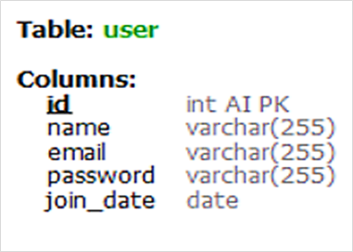**User :**

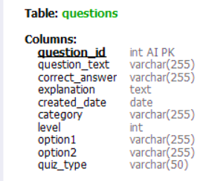**Questions:**

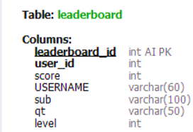**Leader board:**

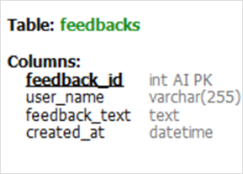**Feedback:**

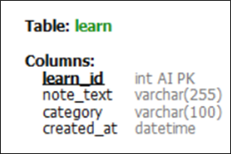**Learn:**

**Coding**

**DATABASE CODING**

**TABLE CREATION USING PYTHON-SQL CONNECTIVITY**

**TABLE USER**

import mysql.connector as mycon

# Connect to MySQL Database

mydb = mycon.connect(

    host="localhost",

    user="root",

    password="root@2024",

    database="sampleproject")

# Create a cursor object

db_cur = mydb.cursor()

# Execute the SQL command to create the user table

# TABLE "USER"

db_cur.execute('''

CREATE TABLE user (

    id INT AUTO_INCREMENT PRIMARY KEY,

    name VARCHAR(255),

    email VARCHAR(255),

    password VARCHAR(255),

    join_date DATE)''')

# Confirm table creation

print("Table created....")

**TABLE QUISTION**

import mysql.connector as mycon

# Connect to MySQL Database

mydb = mycon.connect(

    host="localhost",

    user="root",

    password="root@2024",

    database="sampleproject"

)

# Create a cursor object

db_cur = mydb.cursor()

# Execute the SQL command to create the questions table

db_cur.execute('''

CREATE TABLE questions (

    question_id INT AUTO_INCREMENT PRIMARY KEY,

    question_text VARCHAR(255),

    correct_answer VARCHAR(255),

    explanation TEXT,

    created_date DATE

    category varchar(255)

    level int

    option1 varchar(255)

    option2 varchar(255)

    quiz_type varchar(50)

)

''')

# Confirm table creation

print("Questions table created....")

**TABLE LEARN**

import mysql.connector as mycon

# Connect to MySQL Database

mydb = mycon.connect(

    host="localhost",

    user="root",

    password="root@2024",

    database="sampleproject"

)

# Create a cursor object

db_cur = mydb.cursor()

# Execute the SQL command to create the learn table

db_cur.execute('''

CREATE TABLE learn (

    learn_id INT AUTO_INCREMENT PRIMARY KEY,

    note_text VARCHAR(255),

    subject VARCHAR(255),

    created_date DATE

)

''')

# Confirm table creation

print("Questions table created....")

**TABLE FEEDBACK**

import mysql.connector as mycon

# Connect to MySQL Database

mydb = mycon.connect(

    host="localhost",

    user="root",

    password="root@2024",

    database="sampleproject"

)

# Create a cursor object

db_cur = mydb.cursor()

# Execute the SQL command to create the Feedback table

db_cur.execute('''

CREATE TABLE feedback (

    feedback_id INT AUTO_INCREMENT PRIMARY KEY,

    user_id INT,

    quizz_id INT,

    feedback_text TEXT,

    created_at DATETIME DEFAULT CURRENT_TIMESTAMP,

    FOREIGN KEY (user_id) REFERENCES user(id),

    FOREIGN KEY (quizz_id) REFERENCES quizzes(quiz_id)

)

''')

# Confirm table creation

print("Feedback table created....")

**TABLE LEADER-BOARD**

import mysql.connector as mycon

# Connect to MySQL Database

mydb = mycon.connect(

    host="localhost",

    user="root",

    password="root@2024",

    database="sampleproject"

)

# Create a cursor object

db_cur = mydb.cursor()

# Execute the SQL command to create the leaderboard table with additional columns

db_cur.execute('''

CREATE TABLE leaderboard (

    leaderboard_id INT AUTO_INCREMENT PRIMARY KEY,

    user_id INT,

    score INT,

    FOREIGN KEY (user_id) REFERENCES user(id)

)

''')

# Confirm table creation

print("Leaderboard table created....")

**DATA INNSERTION IN TABLES-**

**DATA IS AUTOMATICALLY INSERTED IN TABLE USER THROUGH REGISTRATION.**

**DATA INSERTION IN TABLE QUESTION:**

import mysql.connector as mycon

from mysql.connector import Error

def insert_computer_science_questions():

    questions = [

        ('What does CPU stand for?', 'Central Processing Unit', 'CPU stands for Central Processing Unit.'),

        ('What is the primary function of the ALU in a computer?', 'Arithmetic and Logic Operations', 'The ALU performs arithmetic and logic operations.'),

        ('What does RAM stand for?', 'Random Access Memory', 'RAM stands for Random Access Memory.'),

        ('What is the full form of HTML?', 'HyperText Markup Language', 'HTML stands for HyperText Markup Language.'),

        ('Who is considered the father of computers?', 'Charles Babbage', 'Charles Babbage is considered the father of computers.'),

        ('What does HTTP stand for?', 'HyperText Transfer Protocol', 'HTTP stands for HyperText Transfer Protocol.'),

        ('What is a binary search?', 'A search algorithm that finds the position of a target value within a sorted array.', 'A binary search finds the position of a target value within a sorted array.'),

        ('What does SQL stand for?', 'Structured Query Language', 'SQL stands for Structured Query Language.'),

        ('What is the main component of a computer system that executes instructions?', 'Processor', 'The processor executes instructions in a computer system.'),

        ('What does GPU stand for?', 'Graphics Processing Unit', 'GPU stands for Graphics Processing Unit.'),

        ('What is the difference between a compiler and an interpreter?', 'A compiler translates the entire code at once, while an interpreter translates code line-by-line.', 'A compiler translates the entire code at once, while an interpreter translates code line-by-line.'),

        ('What is the purpose of an operating system?', 'To manage computer hardware and software resources and provide common services for computer programs.', 'The operating system manages computer hardware and software resources and provides common services for computer programs.'),

        ('What is the full form of URL?', 'Uniform Resource Locator', 'URL stands for Uniform Resource Locator.'),

        ('What does OOP stand for in programming?', 'Object-Oriented Programming', 'OOP stands for Object-Oriented Programming.'),

        ('What is a recursive function?', 'A function that calls itself.', 'A recursive function is a function that calls itself.'),

       ?', 'Domain Name System', 'DNS stands for Domain Name System.'),

        ('What is the difference between a stack and a queue?', 'A stack is LIFO (Last In First Out), while a queue is FIFO (First In First Out).', 'A stack is LIFO (Last In First Out), while a queue is FIFO (First In First Out).'),

        ('What is the full form of XML?', 'eXtensible Markup Language', 'XML stands for eXtensible Markup Language.'),

        ('What is a database?', 'A collection of organized data that can be accessed, managed, and updated.', 'A database is a collection of organized data that can be accessed, managed, and updated.'),

        ('What is the purpose of a loop in programming?', 'To execute a block of code repeatedly.', 'A loop executes a block of code repeatedly.'),

        ('What is a software development lifecycle?', 'A process for planning, creating, testing, and deploying software.', 'A software development lifecycle is a process for planning, creating, testing, and deploying software.'),

        ('What does JSON stand for?', 'JavaScript Object Notation', 'JSON stands for JavaScript Object Notation.'),

        ('What is a hash function?', 'A function that converts an input into a fixed-size string of bytes.', 'A hash function converts an input into a fixed-size string of bytes.'),

        ('What is machine learning?', 'A field of AI that focuses on enabling machines to learn from data.', 'Machine learning is a field of AI that focuses on enabling machines to learn from data.'),

        ('What is the purpose of a version control system?', 'To manage changes to source code over time.', 'A version control system manages changes to source code over time.'),

        ('What is the difference between a virus and a worm?', 'A virus needs a host file to spread, while a worm is a standalone malware that can spread on its own.', 'A virus needs a host file to spread, while a worm is a standalone malware that can spread on its own.'),

        ('What is a neural network?', 'A computational model inspired by the human brain, used in machine learning.', 'A neural network is a computational model inspired by the human brain, used in machine learning.'),

        ('What is the purpose of a cache?', 'To store frequently accessed data for quick access.', 'A cache stores frequently accessed data for quick access.'),

        ('What is the difference between a compiler and an interpreter?', 'A compiler translates the entire code at once, while an interpreter translates code line-by-line.', 'A compiler translates the entire code at once, while an interpreter translates code line-by-line.'),

        ('What is a protocol?', 'A set of rules for transmitting data over a network.', 'A protocol is a set of rules for transmitting data over a network.'),

        ('What is a deadlock in computer science?', 'A situation where two or more processes are unable to proceed because each is waiting for the other to release a resource.', 'A deadlock is a situation where two or more processes are unable to proceed because each is waiting for the other to release a resource.'),

        ('What is the full form of FTP?', 'File Transfer Protocol', 'FTP stands for File Transfer Protocol.'),

        ('What is a heuristic?', 'A technique used to solve a problem faster by finding an approximate solution.', 'A heuristic is a technique used to solve a problem faster by finding an approximate solution.'),

        ('What is recursion?', 'The process of defining something in terms of itself.', 'Recursion is the process of defining something in terms of itself.'),

        ('What is the purpose of an API?', 'To allow different software systems to communicate with each other.', 'An API allows different software systems to communicate with each other.'),

        ('What is a thread in computer science?', 'A unit of execution within a process.', 'A thread is a unit of execution within a process.'),

        ('What is the difference between synchronous and asynchronous communication?', 'Synchronous communication occurs in real-time, while asynchronous communication does not.', 'Synchronous communication occurs in real-time, while asynchronous communication does not.'),

        ('What is the purpose of encryption?', 'To protect data by converting it into a code that cannot be easily read by unauthorized users.', 'Encryption protects data by converting it into a code that cannot be easily read by unauthorized users.')

    ]

    try:

        mydb = mycon.connect(

            host="localhost",

            user="root",

            password="root@2024",

            database="sampleproject"

        )

        db_cur = mydb.cursor()

        for question in questions:

            db_cur.execute('''

            INSERT INTO Questions (question_text, correct_answer, explanation, category)

            VALUES (%s, %s, %s, %s)

            ''', (question[0], question[1], question[2], 'Computer Science'))

        mydb.commit()

        print("50 computer science questions inserted successfully!")

    except Error as e:

        print(f"Error: {e}")

    finally:

        if mydb.is_connected():

            db_cur.close()

            mydb.close()

            print("MySQL connection is closed")

# Call the function to insert computer science questions

insert_computer_science_questions()

**note- data in table is further updated**

**DATA INSERTION IN TABLE LEARN**

import mysql.connector as mycon

from mysql.connector import Error

def insert_learn_data(learn_id, note_text, category, created_at):

try:

# Connect to MySQL database

mydb = mycon.connect(

host="localhost",

user="root",

password="root@2024",

database="sampleproject"

)

# Create a cursor object

db_cur = mydb.cursor()

# Insert data into the learn_data table

db_cur.execute('''

INSERT INTO learn_data (learn_id, note_text, category, created_at)

VALUES (%s, %s, %s, %s)

''', (learn_id, note_text, category, created_at))

# Commit the transaction

mydb.commit()

print(f"Data inserted successfully: {note_text}")

except Error as e:

# Show error message in case of any MySQL error

print(f"Error: {e}")

finally:

# Close the database connection

if mydb.is_connected():

db_cur.close()

mydb.close()

print("MySQL connection is closed")

# Data insertion

insert_learn_data(1, "Water boils at 100°C under standard atmospheric pressure.", "Science", "2025-05-09 03:01:49")

insert_learn_data(2, "H2O is the chemical formula for water, consisting of hydrogen and oxygen.", "Science", "2025-05-09 03:01:49")

insert_learn_data(3, "Albert Einstein introduced the theory of relativity, transforming physics.", "Science", "2025-05-09 03:01:49")

**note- data in table is further updated**

**DATA IS AUTOMATICALLY INSERTED IN TABLE FEEDBACK THROUGH FEEDBACK WINDOW.**

**DATA IS AUTOMATICALLY INSERTED AND UPDATED IN LEADER BOARD TABLE THEOUGH LEADER BOARD WINDOW**

**MODULES CODING**

**THERE ARE THREE FILES:**

* **MAIN_WINDOW.PY**
* **QUIZ.PY**
* **USER_REGISTRATION**

**MAIN_WINDOW.PY**

**IMPORT MODULES AND CONNECT TO SQL:**

import mysql.connector as mycon

from mysql.connector import Error

import tkinter as tk

from tkinter import messagebox

from tkinter import ttk

from tkinter import PhotoImage

import hashlib

from user_registration import register_user

from Quiz import *

def connect_to_db():

    try:

        mydb = mycon.connect(

            host="localhost",

            user="root",

            password="root@2024",

            database="sampleproject"

        )

        return mydb

    except Error as e:

        messagebox.showerror("Error", f"Error connecting to MySQL: {e}")

        return None

**SHOW_START_SCREEN:**

def show_start_screen():

    clear_screen()

    # Ensure the image reference is kept

    global bg_image1_img

    bg_image1_img = tk.PhotoImage(file=r"C:\Users\lenovo\Pictures\user_au.png")

    bg_image1=tk.Label(main_window, image=bg_image1_img)

    bg_image1.place(relheight=1,relwidth=1)

    tk.Label(main_window, text="USER AUTHENTICATION", font=("Times New Roman", 50, "bold"), bg="silver",fg="black").place(relx=0.5, rely=0.4, anchor="center")

    tk.Button(main_window, text="REGISTER", command=show_register_screen,font=("Times New Roman",25,"bold"),bg="silver",fg="gold",width=30).place(relx=0.5, rely=0.80, anchor="center")

    tk.Button(main_window, text="LOGIN", command=show_login_screen, font=("Times New Roman",25,"bold"),bg="silver",fg="gold",width=30).place(relx=0.5, rely=0.65, anchor="center")

def clear_screen():

    for widget in main_window.winfo_children():

        widget.destroy()

main_window=tk.Tk()

main_window.title("Quiz Application")

image_path = PhotoImage(file=r"C:\Users\lenovo\Pictures\home_bgg.png")

logo_path = PhotoImage(file=r"C:\Users\lenovo\Pictures\Quiz_logo.png")

main_window.iconphoto(False, logo_path)  # Set the icon for the main window

bg_image=tk.Label(main_window, image=image_path)

bg_image.place(relheight=1,relwidth=1)

#Main_label=tk.Label(main_window, text="Welcome to Quiz application",font=("Britannic Bold",70,"italic","bold",),bg="silver",fg="black").pack(pady=0)

main_window.geometry('1000x800')

Welcome=tk.Button(main_window, text="Enter", command=show_start_screen, font=("Britannic Bold",50,"italic","bold"),bg="silver",fg="black").pack(pady=360)

main_window.mainloop()

# create a function to quiz window

**SHOW_LOGIN_SCREEN**

def login_user(email, password):

    try:

        hashed_password = hashlib.sha256(password.encode()).hexdigest()

        mydb = mycon.connect(

            host="localhost",

            user="root",

            password="root@2024",

            database="sampleproject"

        )

        db_cur = mydb.cursor()

        db_cur.execute('''

        SELECT * FROM user WHERE email=%s AND password=%s

        ''', (email, hashed_password))

        user = db_cur.fetchone()

        if user:

            db_cur.execute('''

            SELECT name FROM user WHERE email=%s AND password=%s

            ''', (email, hashed_password))

            user_name = db_cur.fetchone()

            user_name = user_name[0]  # Unpack the tuple to get the actual name

            print(f"LOGIN SUCCESSFUL! {user_name}")

            messagebox.showinfo(user_name, "LOGIN SUCCESSFUL!")

            choose(user=user_name)

#            show_topic_selection_screen()  # Call topic selection screen

        else:

            print("Invalid email or password.")

            messagebox.showerror("Error", "Invalid email or password.")

    except Error as e:

        print(f"Error: {e}")

        messagebox.showerror("Error", str(e))

    finally:

        if mydb.is_connected():

            db_cur.close()

            mydb.close()

            print("MySQL connection is closed")

def show_login_screen():

    clear_screen()  # Call function to clear the screen

    global bg_image2_img

    bg_image2_img = tk.PhotoImage(file=r"C:\Users\lenovo\Pictures\login.png")

    bg_image2=tk.Label(main_window, image=bg_image2_img)

    bg_image2.place(relheight=1,relwidth=1)

    # Create label with text, font & grid using tk

    tk.Label(main_window, text="LOGIN",font=("Times New Roman", 50, "bold"), bg="silver",fg="black").grid(row=0, columnspan=2, pady=20, padx=10)

    # Create the label and entry for email using ttk

    ttk.Label(main_window, text="EMAIL:", font=("Modern No. 20", 30,"italic")).grid(row=1, column=0, padx=20, pady=10, sticky="W")

    entry_login_email = ttk.Entry(main_window, width=50)

    entry_login_email.grid(row=1, column=1, padx=20, pady=10)

    # Create the label and entry for password using ttk

    ttk.Label(main_window, text="PASSWORD:", font=("Modern No. 20", 30,"italic")).grid(row=2, column=0, padx=20, pady=10, sticky="W")

    entry_login_password = ttk.Entry(main_window, show='*', width=50)

    entry_login_password.grid(row=2, column=1, padx=20, pady=10)

    # Create the Login and Back buttons with increased size

    ttk.Button(main_window, text="LOGIN", command=lambda: login_user(entry_login_email.get(), entry_login_password.get()), width=40).grid(row=3, columnspan=2, pady=20, ipadx=20, ipady=10)

    ttk.Button(main_window, text="BACK", command=show_start_screen, width=40).grid(row=4, columnspan=2, pady=10, ipadx=20, ipady=10)

**SHOW_REGISTRATION_SCREEN**

def show_register_screen():

    clear_screen()  # Call function to clear the screen

    global bg_image3_img

bg_image3_img = tk.PhotoImage(file=r"C:\Users\lenovo\Pictures\registration.png")

    bg_image3=tk.Label(main_window, image=bg_image3_img)

    bg_image3.place(relheight=1,relwidth=1)

    # Create label with text, font & grid using tk

    tk.Label(main_window, text="REGISTRATION", font=("Times New Roman", 50, "bold"), bg="silver",fg="Black").grid(row=0, columnspan=2, pady=20)

    # Create the label and entry for name using ttk

    ttk.Label(main_window, text="NAME:", font=("Modern No. 20", 30,"italic")).grid(row=1, column=0, padx=20, pady=10, sticky="e")

    entry_name = ttk.Entry(main_window, width=50)

    entry_name.grid(row=1, column=1, padx=20, pady=10)

    # Create the label and entry for email using ttk

    ttk.Label(main_window, text="EMAIL:", font=("Modern No. 20", 30,"italic")).grid(row=2, column=0, padx=20, pady=10, sticky="e")

    entry_email = ttk.Entry(main_window, width=50)

    entry_email.grid(row=2, column=1, padx=20, pady=10)

    # Create the label and entry for password using ttk

    ttk.Label(main_window, text="PASSWORD:", font=("Modern No. 20", 30,"italic")).grid(row=3, column=0, padx=20, pady=10, sticky="e")

    entry_password = ttk.Entry(main_window, show='*', width=50)

    entry_password.grid(row=3, column=1, padx=20, pady=10)

    # Create the Register and Back buttons with increased size

    ttk.Button(main_window, text="REGISTER", command=lambda: register_user(entry_name.get(), entry_email.get(), entry_password.get()), width=30).grid(row=4, columnspan=2, pady=20, ipadx=20, ipady=10)

    ttk.Button(main_window, text="BACK", command=show_start_screen, width=30).grid(row=5, columnspan=2, pady=10, ipadx=20, ipady=10)

def show_login_screen():

    clear_screen()  # Call function to clear the screen

    global bg_image2_img

    bg_image2_img = tk.PhotoImage(file=r"C:\Users\lenovo\Pictures\login.png")

    bg_image2=tk.Label(main_window, image=bg_image2_img)

    bg_image2.place(relheight=1,relwidth=1)

    # Create label with text, font & grid using tk

    tk.Label(main_window, text="LOGIN",font=("Times New Roman", 50, "bold"), bg="silver",fg="black").grid(row=0, columnspan=2, pady=20, padx=10)

    # Create the label and entry for email using ttk

    ttk.Label(main_window, text="EMAIL:", font=("Modern No. 20", 30,"italic")).grid(row=1, column=0, padx=20, pady=10, sticky="W")

    entry_login_email = ttk.Entry(main_window, width=50)

    entry_login_email.grid(row=1, column=1, padx=20, pady=10)

    # Create the label and entry for password using ttk

    ttk.Label(main_window, text="PASSWORD:", font=("Modern No. 20", 30,"italic")).grid(row=2, column=0, padx=20, pady=10, sticky="W")

    entry_login_password = ttk.Entry(main_window, show='*', width=50)

    entry_login_password.grid(row=2, column=1, padx=20, pady=10)

    # Create the Login and Back buttons with increased size

    ttk.Button(main_window, text="LOGIN", command=lambda: login_user(entry_login_email.get(), entry_login_password.get()), width=40).grid(row=3, columnspan=2, pady=20, ipadx=20, ipady=10)

    ttk.Button(main_window, text="BACK", command=show_start_screen, width=40).grid(row=4, columnspan=2, pady=10, ipadx=20, ipady=10)

**CHOOSE**

def choose(user):

    clear_screen()

    print(user)

    global bg_image4_img

    bg_image4_img = tk.PhotoImage(file=r"C:\Users\lenovo\Pictures\choose.png")

    bg_image4 = tk.Label(image=bg_image4_img)

    bg_image4.place(relheight=1, relwidth=1)

    style = ttk.Style()

    style.configure("Custom.TButton", font=("Helvetica", 15), background="#D5F5E3", foreground="#154360", padding=10)

    tk.Label(main_window, text="CHOOSE YOUR WAY", font=("Helvetica", 50, "bold"), bg="silver", fg="black").grid(row=1, columnspan=2, pady=20)

    # Create Notebook for Tabs (Q&A and About)

    notebook = ttk.Notebook(main_window)

    blank_tab = ttk.Frame(notebook)

    qna_tab = ttk.Frame(notebook)

    about_tab = ttk.Frame(notebook)

    notebook.add(blank_tab, text=" ")

    notebook.add(qna_tab, text="    FAQs    ")

    notebook.add(about_tab, text="  About us    ")

    notebook.grid(row=0, column=0, columnspan=2, padx=15, pady=0, sticky="nsew")

     # Bind tab selection to open respective function

    notebook.bind("<<NotebookTabChanged>>", open_tab_function)

    way = ["LEARN", "QUIZ", "LEADERBOARD", "FEEDBACK"]

    # Display topics using ttk buttons

    for index, option in enumerate(way):

        ttk.Button(main_window, text=option, command=lambda w=option: next_window(way=w, curent_user=user), width=40).grid(row=index+2, column=0, columnspan=2, pady=10, ipadx=20, ipady=10)

    # Create the Back button

    ttk.Button(main_window, text="BACK", command=show_login_screen, width=50, style="Custom.TButton").grid(row=len(way)+3, columnspan=4, pady=20, ipadx=20, ipady=10)

**TABS**

def open_tab_function(event):

    """Opens respective window only when a tab is manually clicked"""

    print("DEBUG: open_tab_function called")

    notebook = event.widget  # Correctly get the notebook instance from the event

    selected_tab = notebook.tab(notebook.select(), "text")

    print(f"DEBUG: Selected tab: {selected_tab}")

    # Ensure tab was manually clicked (not the default selection on window load)

    if notebook.index(notebook.select()) > 0:

        print(f"DEBUG: Tab index is {notebook.index(notebook.select())}, opening window for tab: {selected_tab}")

        if selected_tab == " ":

            print("DEBUG: Opening Blank Tab window")

            SHow_blank_tab()

        elif selected_tab == "    FAQs    ":

            print("DEBUG: Opening Q&A window")

            show_qna_window()

        elif selected_tab == "  About us    ":

            print("DEBUG: Opening About window")

            show_about_window()

    else:

        print("DEBUG: Default tab selected, no action taken")

**LEARN**

def show_learn_screen():

    clear_screen()  # Call function to clear the screen

    global bg_image5_img

    bg_image5_img = tk.PhotoImage(file=r"C:\Users\lenovo\Pictures\learn.png")

    bg_image5=tk.Label(main_window, image=bg_image5_img)

    bg_image5.place(relheight=1,relwidth=1)

    # Create label with text, font & grid using tk

    tk.Label(main_window, text="LEARN", font=("Helvetica", 50, "bold"), bg="silver", fg="black").grid(row=0, columnspan=2, pady=20)

    subjects = ["SCIENCE", "MATH", "COMPUTER SCIENCE", "SOCIAL SCIENCE"]

    for index, subject in enumerate(subjects):

        ttk.Button(main_window, text=subject, command=lambda s=subject: show_notes_screen(s), width=40).grid(row=index + 1, column=0, columnspan=2, pady=10, ipadx=20, ipady=10)

    # Create the Back button

    ttk.Button(main_window, text="BACK", command=lambda: choose(user=None), width=50).grid(row=len(subjects) + 1, columnspan=2, pady=20, ipadx=20, ipady=10)

**QUIZ**

def show_quiz_type_selection_screen(topic, person):

    clear_screen()

    # Load and set the background image

    global bg_image_quiz_type

    bg_image_quiz_type = tk.PhotoImage(file=r"C:\Users\lenovo\Pictures\quiz_type.png")  # Update the path to your image file

    bg_label = tk.Label(main_window, image=bg_image_quiz_type)

    bg_label.place(relheight=1, relwidth=1)  # Make the image cover the entire window

    # Create label for quiz type selection title

    tk.Label(main_window, text=f"SELECT QUIZ TYPE ({topic})", font=("Helvetica", 40, "bold"), bg="light blue").grid(row=0, columnspan=2, pady=20)

    quiz_types = ["MCQs", "Fill in the Blanks", "True/False"]

    for index, quiz_type in enumerate(quiz_types):

        ttk.Button(main_window, text=quiz_type, command=lambda q=quiz_type: start_quiz(topic, q, person), width=40).grid(row=index+1, column=0, columnspan=2, pady=10, ipadx=20, ipady=10)

    ttk.Button(main_window, text="BACK", command=lambda: show_topic_selection_screen(person), width=50, style="Custom.TButton").grid(row=len(quiz_types)+1, columnspan=2, pady=20, ipadx=20, ipady=10)

def start_quiz(topic, quiz_type, consumer):

    print(f"STARTING QUIZ ON TOPIC: {topic}, TYPE: {quiz_type}, for {consumer}")

    messagebox.showinfo("QUIZ", f"STARTING {quiz_type} Quiz on {topic}")

    start_quizz(topic, quiz_type, level=1, coustmer=consumer)  # Pass quiz type & level

**LEADER-BOARD**

def show_leaderboard_screen(human):

    clear_screen()  # Clear previous screen

    global bg_image6_img

    # Connect to the database

    mydb = connect_to_db()

    if mydb:

        # Load background image

        bg_image6_img = tk.PhotoImage(file=r"C:\Users\lenovo\Pictures\leaderboard.png")

        bg_image6 = tk.Label(main_window, image=bg_image6_img)

        bg_image6.place(relheight=1, relwidth=1)

        # Add Leader-board title

        tk.Label(

            main_window,

            text="LEADER-BOARD",

            font=("Helvetica", 50, "bold"),

            bg="silver",

            fg="black"

        ).place(relx=0.5, rely=0.05, anchor="center")

        try:

            # Fetch leaderboard data

            db_cur = mydb.cursor()

            db_cur.execute("SELECT * FROM leaderboard ORDER BY score DESC")

            leaderboard = db_cur.fetchall()

            # Create a frame for leaderboard and scrolling

            frame = tk.Frame(main_window, bg="silver")

            frame.place(relx=0.1, rely=0.15, relwidth=0.85, relheight=0.7)

            # Create a canvas and scrollbar

            canvas = tk.Canvas(frame, bg="silver")

            scrollbar = tk.Scrollbar(frame, orient="vertical", command=canvas.yview)

            scrollable_frame = tk.Frame(canvas, bg="silver")

            # Configure scrolling

            scrollable_frame.bind("<Configure>", lambda e: canvas.configure(scrollregion=canvas.bbox("all")))

            canvas.create_window((0, 0), window=scrollable_frame, anchor="nw")

            canvas.configure(yscrollcommand=scrollbar.set)

            # Pack scrollbar and canvas

            canvas.pack(side="left", fill="both", expand=True)

            scrollbar.pack(side="right", fill="y")

            # Display leaderboard records

            if leaderboard:

                # Add column headers using a grid for tabular layout

                headers = ["Sno.", "Marks", "Name", "Subject", "Quiz-type","Level"]

                for col, header in enumerate(headers):

                    tk.Label(

                        scrollable_frame,

                        text=header,

                        font=("Helvetica", 18, "bold"),

                        bg="silver",

                        fg="blue",

                        borderwidth=1,

                        relief="solid",

                        width=14

                    ).grid(row=0, column=col, padx=1, pady=2, sticky="nsew")

                for index, record in enumerate(leaderboard):

                    values = [

                        str(index + 1),

                        str(record[2]),

                        str(record[3]),

                        str(record[4]),

                        str(record[5]),

                        f"{record[6]}"

                    ]

                    for col, value in enumerate(values):

                        tk.Label(

                            scrollable_frame,

                            text=value,

                            font=("Helvetica", 16),

                            bg="silver",

                            fg="black",

                            borderwidth=1,

                            relief="solid",

                            width=14

                        ).grid(row=index + 1, column=col, padx=1, pady=2, sticky="nsew")

            else:

                tk.Label(

                    scrollable_frame,

                    text="No records found.",

                    font=("Helvetica", 20),

                    bg="silver",

                    fg="black"

                ).pack(pady=10)

        except Error as e:

            messagebox.showerror("Error", f"Error fetching leaderboard: {e}")

        finally:

            if mydb.is_connected():

                db_cur.close()

                mydb.close()

        # Back button

        tk.Button(

            main_window,

            text="Back",

            font=("Helvetica", 15),

            bg="silver",

            fg="gold",

            command=lambda: choose(user=human)

        ).place(relx=0.4, rely=0.9, relwidth=0.2)

**FEEDBACK**

def show_feedback_screen():

    clear_screen()  # Call function to clear the screen

    global bg_image7_img

    bg_image7_img = tk.PhotoImage(file=r"C:\Users\lenovo\Pictures\feedback.png")

    bg_image7 = tk.Label(main_window, image=bg_image7_img)

    bg_image7.place(relheight=1, relwidth=1)

    # Create label with text, font & grid using tk

    tk.Label(main_window, text="FEEDBACK", font=("Helvetica", 50, "bold"), bg="silver", fg="black").grid(row=0, columnspan=2, pady=20)

    # crete the label and entry for name and feedback using ttk

    ttk.Label(main_window, text="USER NAME:", font=("Modern No. 20", 30, "italic")).grid(row=1, column=0, padx=20, pady=10, sticky="e")

    entry_name = ttk.Entry(main_window, width=50)

    entry_name.grid(row=1, column=1, padx=20, pady=10)

    ttk.Label(main_window, text="FEEDBACK:", font=("Modern No. 20", 30, "italic")).grid(row=2, column=0, padx=20, pady=10, sticky="e")

    entry_feedback = ttk.Entry(main_window, width=50)

    entry_feedback.grid(row=2, column=1, padx=20, pady=10)

    # Create the Submit and Back buttons with increased size

    ttk.Button(main_window, text="SUBMIT", command=lambda: submit_feedback(entry_name.get(), entry_feedback.get()), width=30).grid(row=3, columnspan=2, pady=20, ipadx=20, ipady=10)

    ttk.Button(main_window, text="BACK", command=lambda: choose(user=None), width=30).grid(row=4, columnspan=2, pady=10, ipadx=20, ipady=10)

**QUIZ.PY**

**IMPORT MODULES AND CONNECT TO SQL:**

import tkinter as tk

from tkinter import messagebox

import mysql.connector as mycon

from mysql.connector import Error

import random

import time

from PIL import Image, ImageTk

from tkinter import PhotoImage

def connect_to_db():

    try:

        mydb = mycon.connect(

            host="localhost",

            user="root",

            password="root@2024",

            database="sampleproject"

        )

        return mydb

    except Error as e:

        messagebox.showerror("Error", f"Error connecting to MySQL: {e}")

        return None

**FETCH QUESTIONS:**

def fetch_questions(topic, level, quiz_type):

    mydb = connect_to_db()

    if mydb:

        try:

            db_cur = mydb.cursor()

            db_cur.execute('''

            SELECT question_text, option1, option2, correct_answer, explanation

            FROM questions

            WHERE category=%s AND level=%s AND quiz_type=%s

            ''', (topic, level, quiz_type))

            questions = db_cur.fetchall()

            return questions

        except Error as e:

            messagebox.showerror("Error", f"Error fetching questions: {e}")

        finally:

            if mydb.is_connected():

                db_cur.close()

                mydb.close()

**SAVE SCORE:**

def save_score(score, username, Subject ,Quiz_type, level):

    mydb = connect_to_db()

    if mydb:

        try:

            db_cur = mydb.cursor()

            db_cur.execute('''

            INSERT INTO leaderboard (score, USERNAME, sub, qt, level) VALUES (%s, %s, %s, %s, %s)

            ''', (score, username, Subject, Quiz_type, level))

            mydb.commit()

            print(f"Saving score: {score} , username: {username}")

        except Error as e:

            messagebox.showerror("Error", f"Error saving score: {e}")

        finally:

            if mydb.is_connected():

                db_cur.close()

                mydb.close()

**DISPLAY QUESTIONS:**

def display_question(quiz_window, question, options, correct_answer, next_question_callback, score_label, score, quiz_type):

    question_label = tk.Label(quiz_window, text=question, font=("Helvetica", 20))

    question_label.pack(pady=10)

    def check_answer(selected_option=None):

        nonlocal score

        user_answer = selected_option if quiz_type in ['MCQs', 'True/False'] else answer_entry.get().strip()

        if user_answer.lower() == correct_answer.lower():

            score += 10

            messagebox.showinfo("Correct!", f"Correct! Your score is: {score}")

        else:

            messagebox.showerror("Wrong!", f"Wrong! Correct answer: {correct_answer}")

        score_label.config(text=f"Score: {score}")

        next_question_callback()

    if quiz_type in ['MCQs', 'True/False']:

        random.shuffle(options)

        for option in options:

            tk.Button(quiz_window, text=option, font=("Helvetica", 15),

                      command=lambda opt=option: check_answer(opt)).pack(pady=5)

    else:  # Fill in the Blanks

        answer_entry = tk.Entry(quiz_window, font=("Helvetica", 15))

        answer_entry.pack(pady=10)

        submit_button = tk.Button(quiz_window, text="Submit Answer", font=("Helvetica", 15),

                                  command=check_answer)

        submit_button.pack(pady=10)

**COUNTDOWN TIMER:**

def countdown_timer(canvas, duration, when_done):

    """Show a countdown label on the supplied canvas."""

    lbl = tk.Label(canvas, font=("Helvetica", 20), bg="white")

    canvas.create_window(800, 20, window=lbl, tags="widgets")

    def tick(t):

        if t >= 0:

            lbl.config(text=f"Time left: {t}s")

            canvas.after(1_000, tick, t - 1)

        else:

            messagebox.showinfo("Time's up!", "Moving to the next question.")

            when_done()

    tick(duration)

**START QUIZ:**

def start_quizz(topic, quiz_type, level=1, coustmer=None):

    """

    Launch a quiz window on a given topic / type / level.

    `coustmer` (original spelling preserved) is the player name.

    """

    # ------------------------------------------------------------------

    # window + background

    # ------------------------------------------------------------------

    quiz_window = tk.Toplevel()

    quiz_window.title(f"Quiz – {topic} ({quiz_type}, Level {level})")

    quiz_window.geometry("800x600")

    logo_path = PhotoImage(file=r"C:\Users\lenovo\Pictures\Quiz_logo.png")

    quiz_window.iconphoto(False, logo_path)  # Set the icon for the main window

    bg_img_pil = Image.open(r"C:\Users\lenovo\Documents\python_project_4th_file\.dist\quiz.png").resize((1550, 800), Image.LANCZOS)

    bg_photo   = ImageTk.PhotoImage(bg_img_pil)

    quiz_window.bg_reference = bg_photo        # keep a reference!

    canvas = tk.Canvas(quiz_window, width=1550, height=800, highlightthickness=0)

    canvas.pack(fill="both", expand=True)

    canvas.create_image(0, 0, image=bg_photo, anchor="nw")

    # ------------------------------------------------------------------

    # quiz state

    # ------------------------------------------------------------------

    score           = 0

    question_index  = 0

    questions       = fetch_questions(topic, level, quiz_type)

    # ------------------------------------------------------------------

    # helpers

    # ------------------------------------------------------------------

    def proceed_to_next_level():

        """Advance when pass-mark reached; else show topic menu."""

        needed = 50 if quiz_type == "MCQs" else 30

        if score >= needed:

            if level < 5:

                messagebox.showinfo(

                    "Level Up!",

                    f"Congratulations! You've passed Level {level} with a score of {score}.\n"

                    "Proceeding to the next level..."

                )

                start_quizz(topic, quiz_type, level + 1, coustmer)

            else:

                messagebox.showinfo("Quiz Completed", "You've finished every level!")

        else:

            messagebox.showwarning(f"your score is {score}",

                "minimum 50 points for MCQs, 30 points for fill in the blanks and True/False needed to pass level.\n")

            from main_window import show_topic_selection_screen

            show_topic_selection_screen(coustmer)

    def quit_quiz():

        if messagebox.askyesno("Quit", "Are you sure you want to quit the quiz?"):

            save_score(score, coustmer, topic, quiz_type, level)

            quiz_window.destroy()

    # static widgets (score + quit)

    score_lbl  = tk.Label(quiz_window, text=f"Score: {score}", font=("Helvetica", 20), bg="white")

    canvas.create_window(800, 60, window=score_lbl, tags="static")

    quit_btn   = tk.Button(quiz_window, text="Quit", font=("Helvetica", 15), command=quit_quiz)

    canvas.create_window(800, 100, window=quit_btn, tags="static")

    # ------------------------------------------------------------------

    # per-question workflow

    # ------------------------------------------------------------------

    def next_question():

        nonlocal question_index, score

        canvas.delete("widgets")        # clear previous dynamic widgets

        if question_index >= len(questions):

            # end of level

            save_score(score, coustmer, topic, quiz_type, level)

            proceed_to_next_level()

            quiz_window.destroy()

            return

        q_text, opt1, opt2, correct, expl = questions[question_index]

        question_index += 1

        # show question text

        q_lbl = tk.Label(

            quiz_window, text=q_text,

            font=("Helvetica", 20), bg="white",

            wraplength=700, justify="center"

        )

        canvas.create_window(800, 180, window=q_lbl, tags="widgets")

        # answer-check closure

        def check_answer(user_answer):

            nonlocal score

            if user_answer.strip().lower() == correct.lower():

                score += 10

                messagebox.showinfo("Correct!", f"Correct! Your score is now {score}.")

            else:

                messagebox.showerror(

                    "Wrong!",

                    f"Wrong! Correct answer: {correct}\n\nExplanation:\n{expl}"

                )

            score_lbl.config(text=f"Score: {score}")

            next_question()   # recurse

**USER_REGISTRATION:**

**IMPORT FILES:**

import mysql.connector as mycon

from mysql.connector import Error

import hashlib

from tkinter import messagebox  # Import messagebox to show alerts in GUI

**USER_REGISTRATION:**

def register_user(name, email, password):

     # Minimum password length

    MIN_PASSWORD_LENGTH = 8

    if len(password) < MIN_PASSWORD_LENGTH:

        messagebox.showerror("Error", f"Password must be at least {MIN_PASSWORD_LENGTH} characters long.")

        return

    try:

        hashed_password = hashlib.sha256(password.encode()).hexdigest()

        print("\nPassword hashed.")

        mydb = mycon.connect(

            host="localhost",

            user="root",

            password="root@2024",

            database="sampleproject"  )

        print("Connected to MySQL Database.")

        db_cur = mydb.cursor()

        print("Cursor created.")

        db_cur.execute('''

        INSERT INTO user(name, email, password, join_date)

        VALUES (%s, %s, %s, CURDATE())

        ''', (name, email, hashed_password))

        print("User details inserted.")

        mydb.commit()

        print("User registered successfully!")

        messagebox.showinfo("Success", "User registered successfully!")

    except Error as e:

        print(f"Error: {e}")

        messagebox.showerror("Error", str(e))

    finally:

        if mydb.is_connected():

            db_cur.close()

            mydb.close()

            print("MySQL connection is closed")

**ER-TABLE**

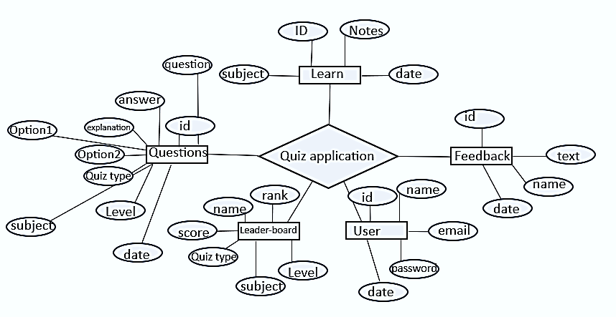

**Project Snapshots**

**WINDOW HOME SCREEN**

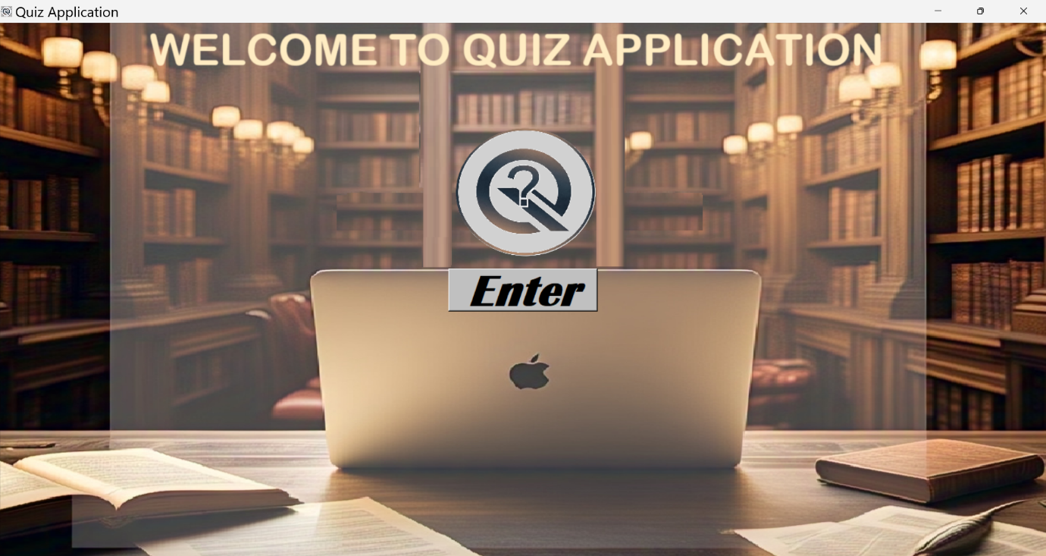

**USER_AUNTHETICATION_SCREEN**

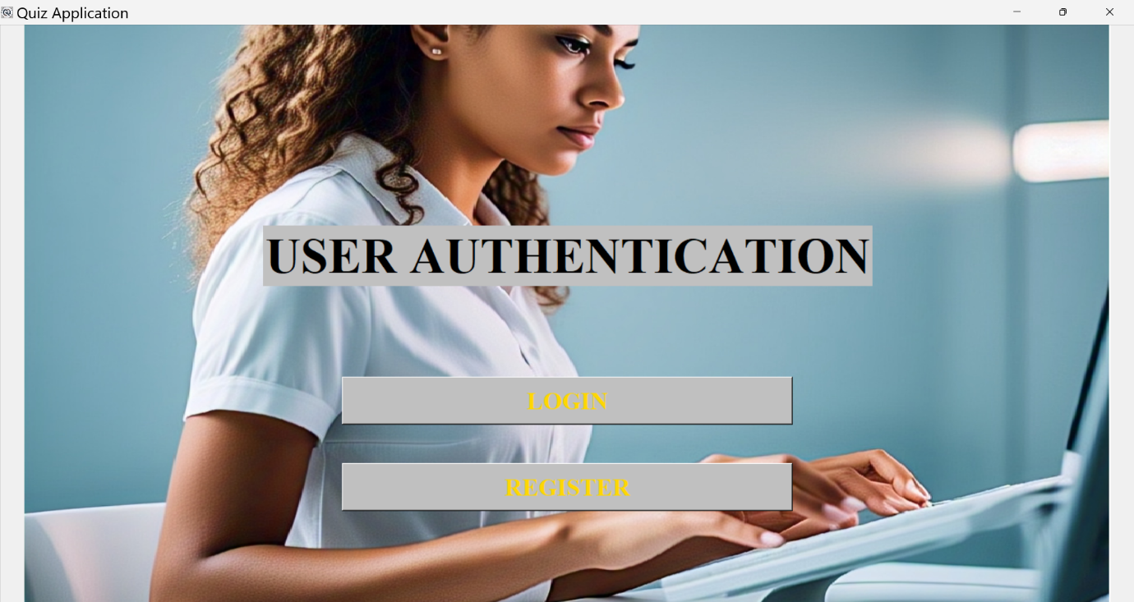

**REGISTER SCREEN**

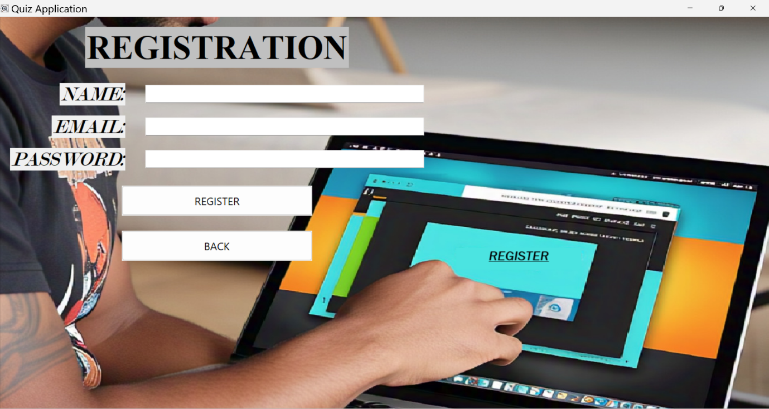

**LOGIN SCREEN**

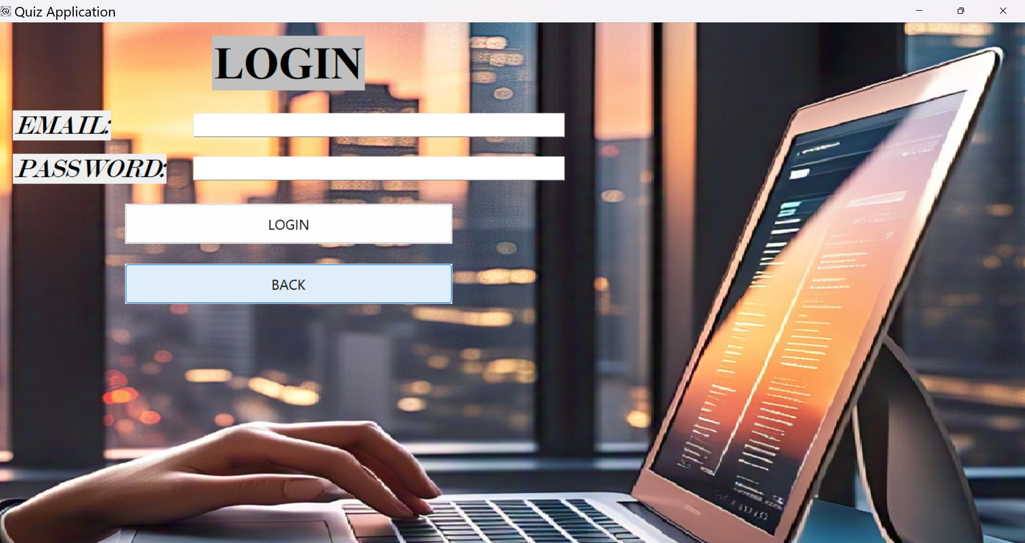

**CHOOSE YOUR WAY SCREEN**

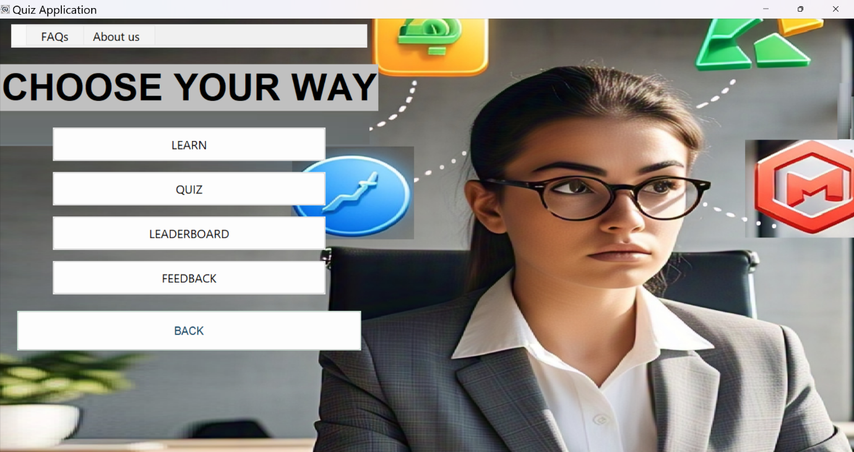

**TABS(Q&A SCREEN)**

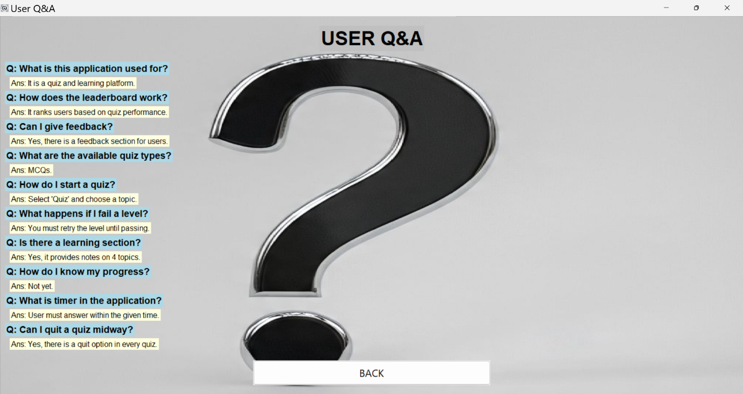

**TABS(ABOUT APPLICATION SCREEN)**

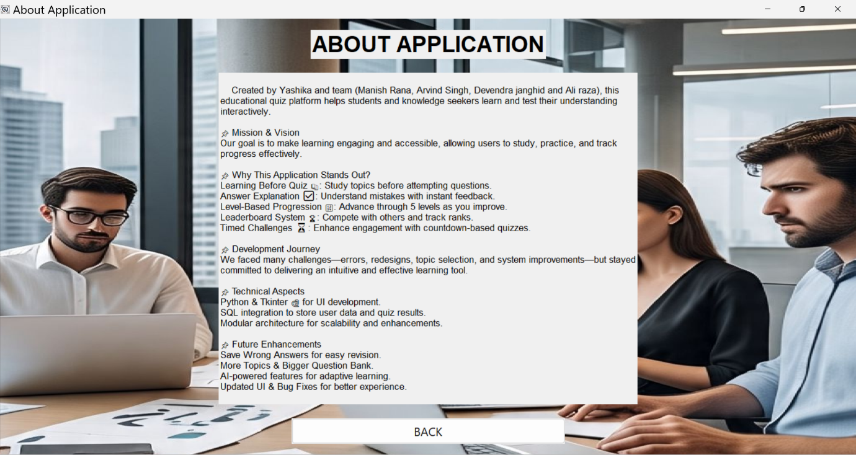

**LEARN SCREEN**

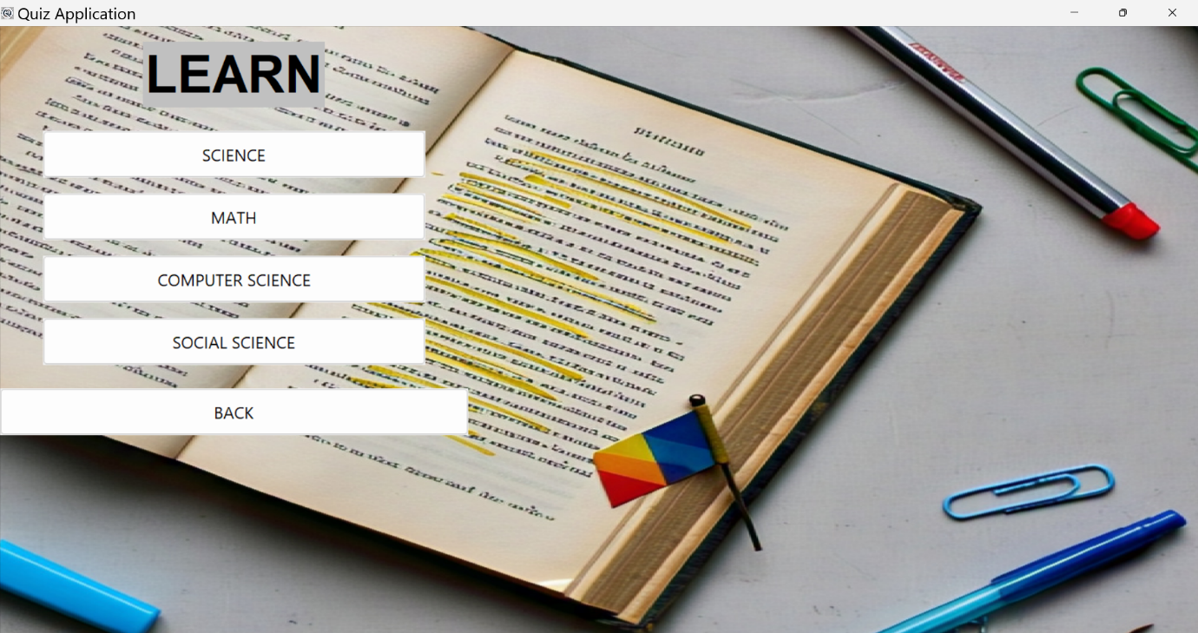

**NOTES SCREEN**

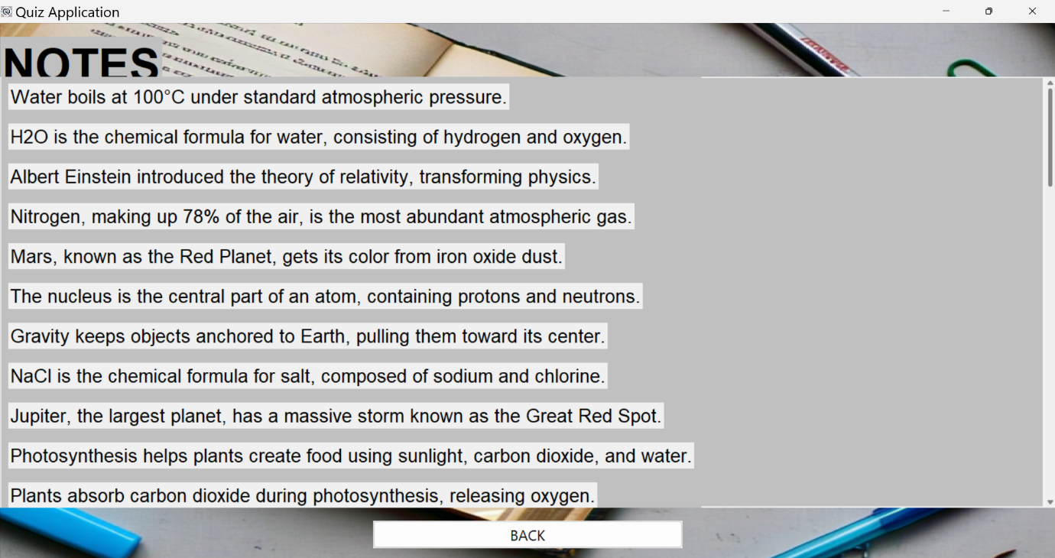

**TOPIC SELECTION SCREEN**

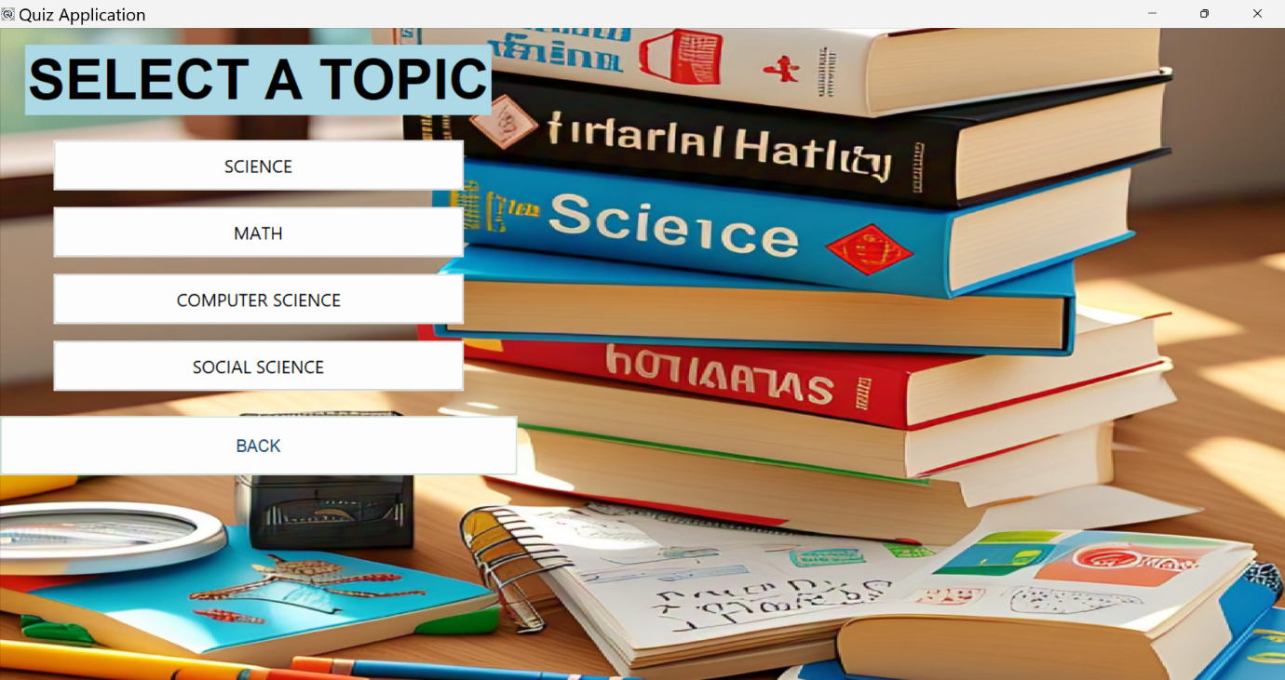

**QUIZ SCREEN**

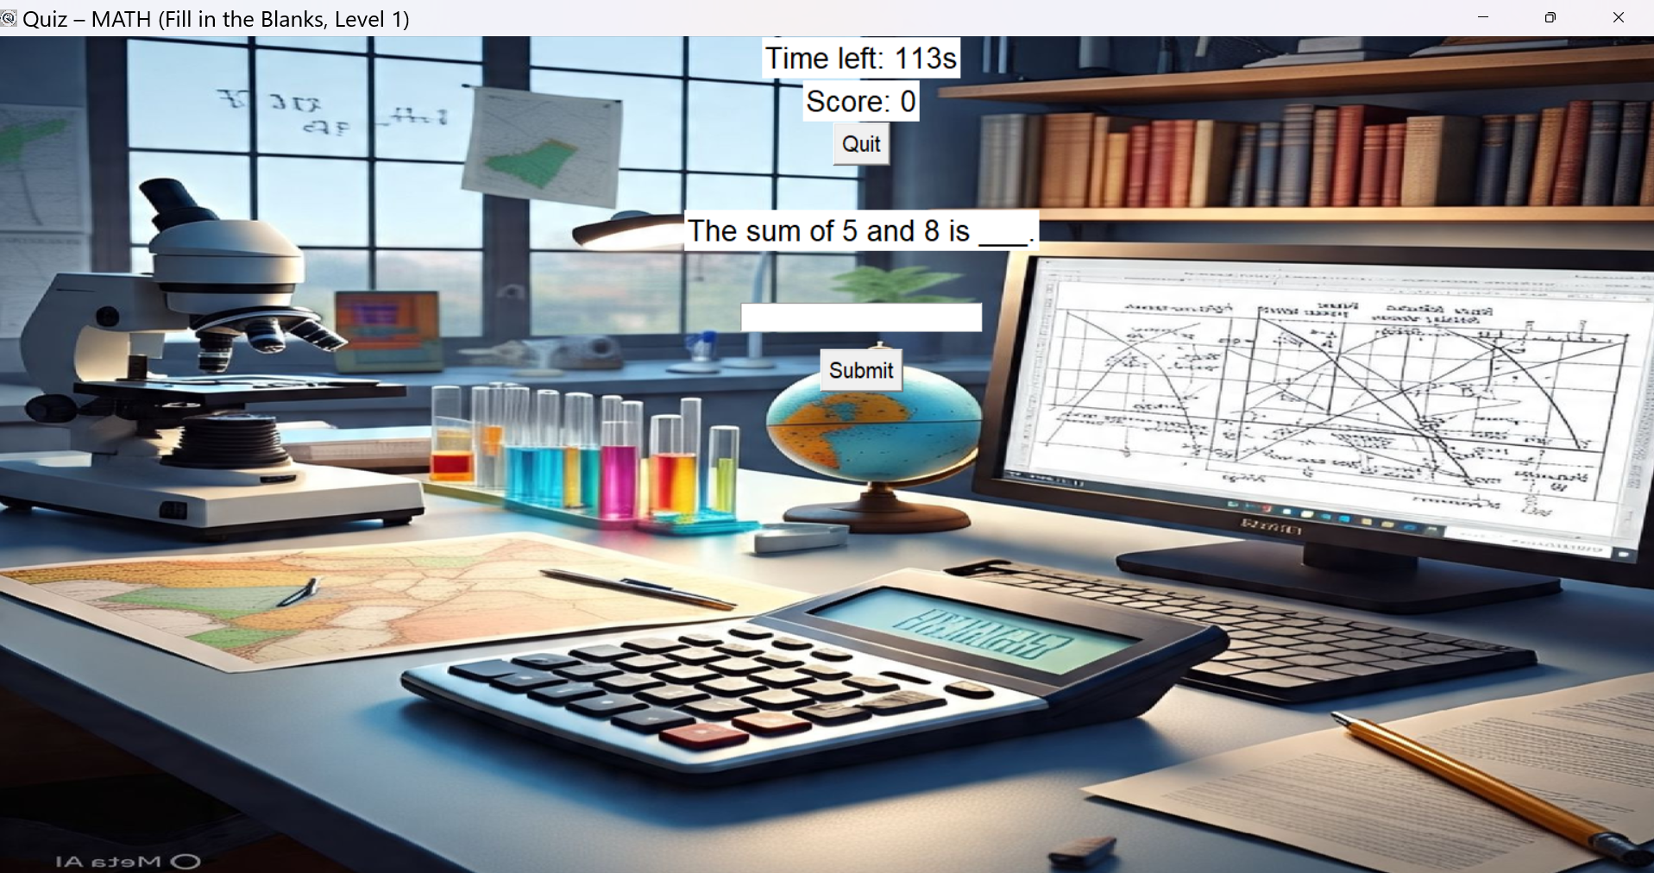

**LEADER-BOARD SCREEN**

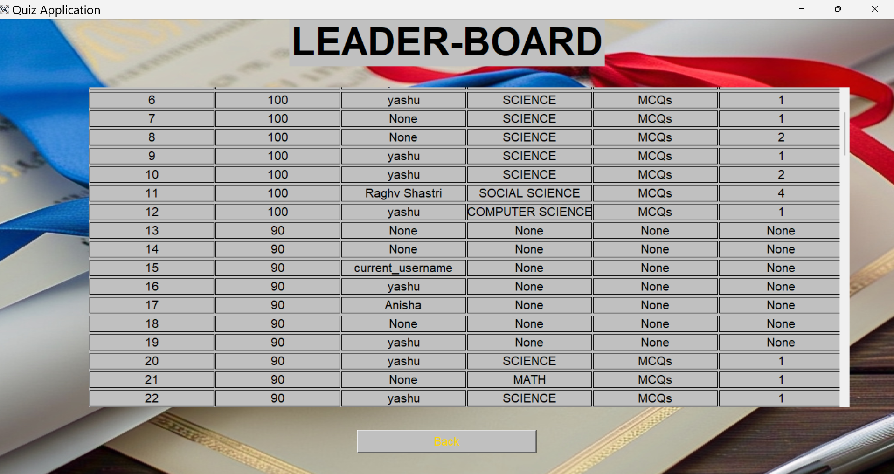

**FEEDBACK SCREEN**

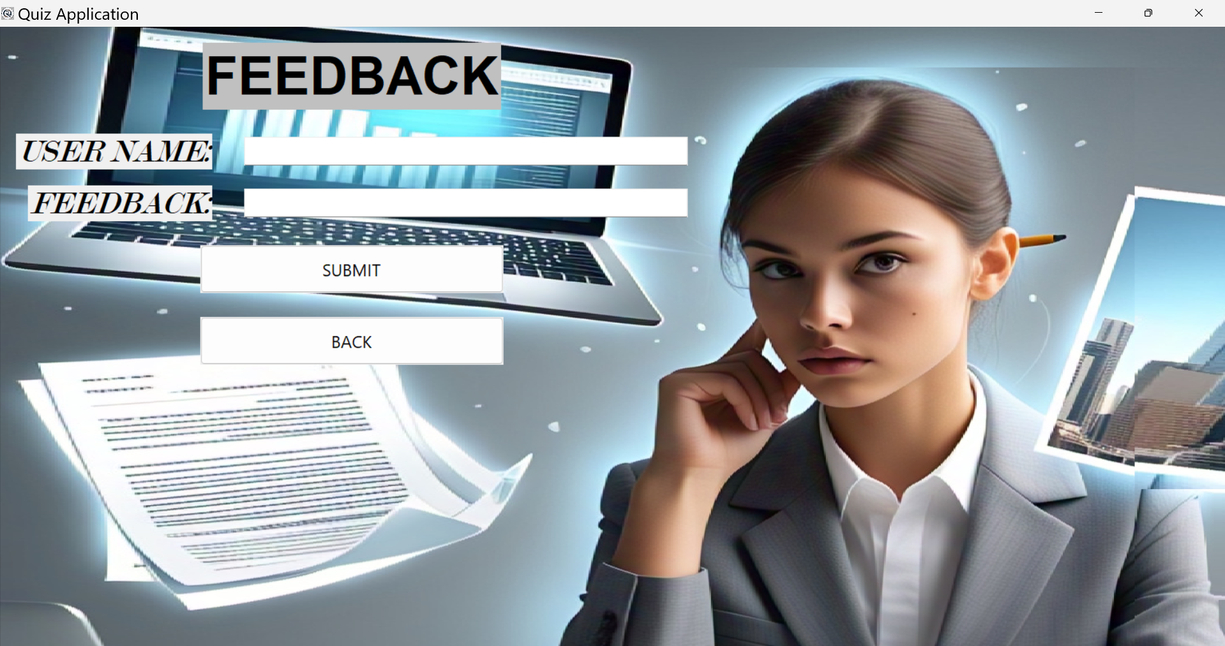

**REPORT SNAPSHOTS**

**USER REPORT**

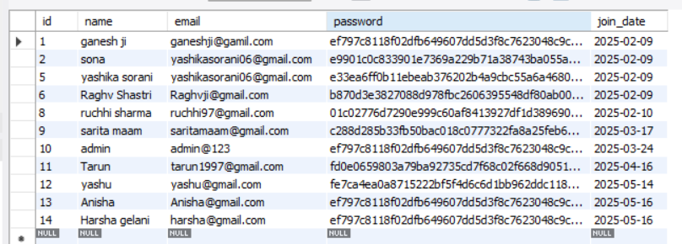

**QUESTIONS REPORT**

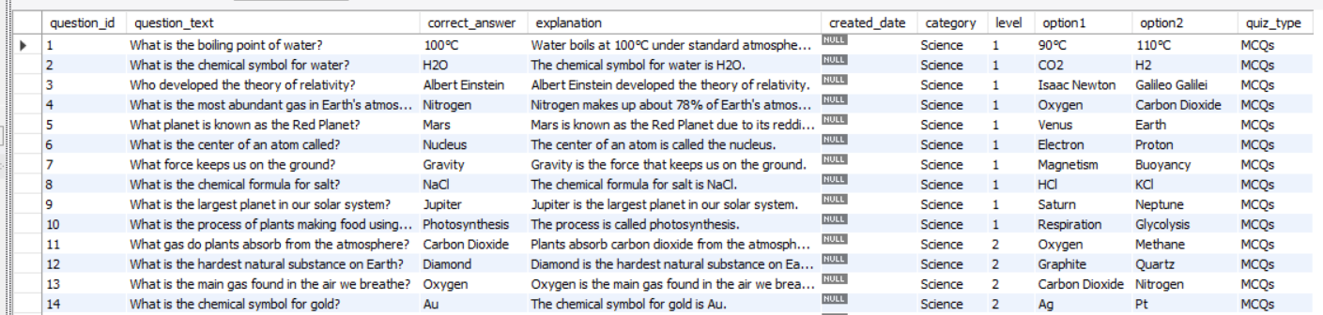

**LEARN REPORT**

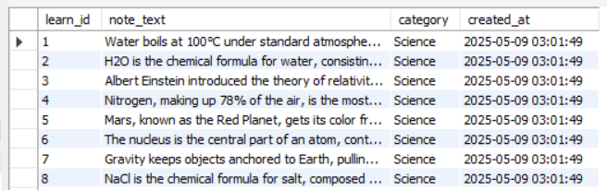

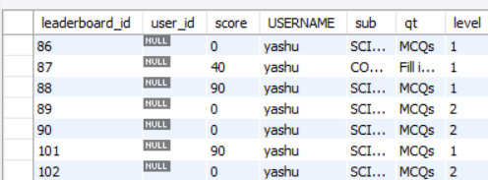**LEADER-BOARD REPORT**

**FEEDBACK REPORT**

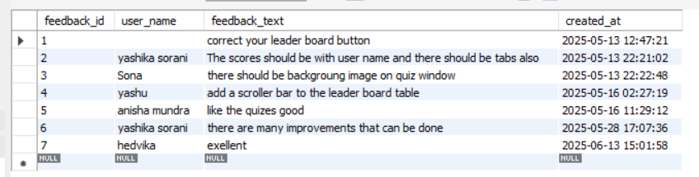

**About Us**

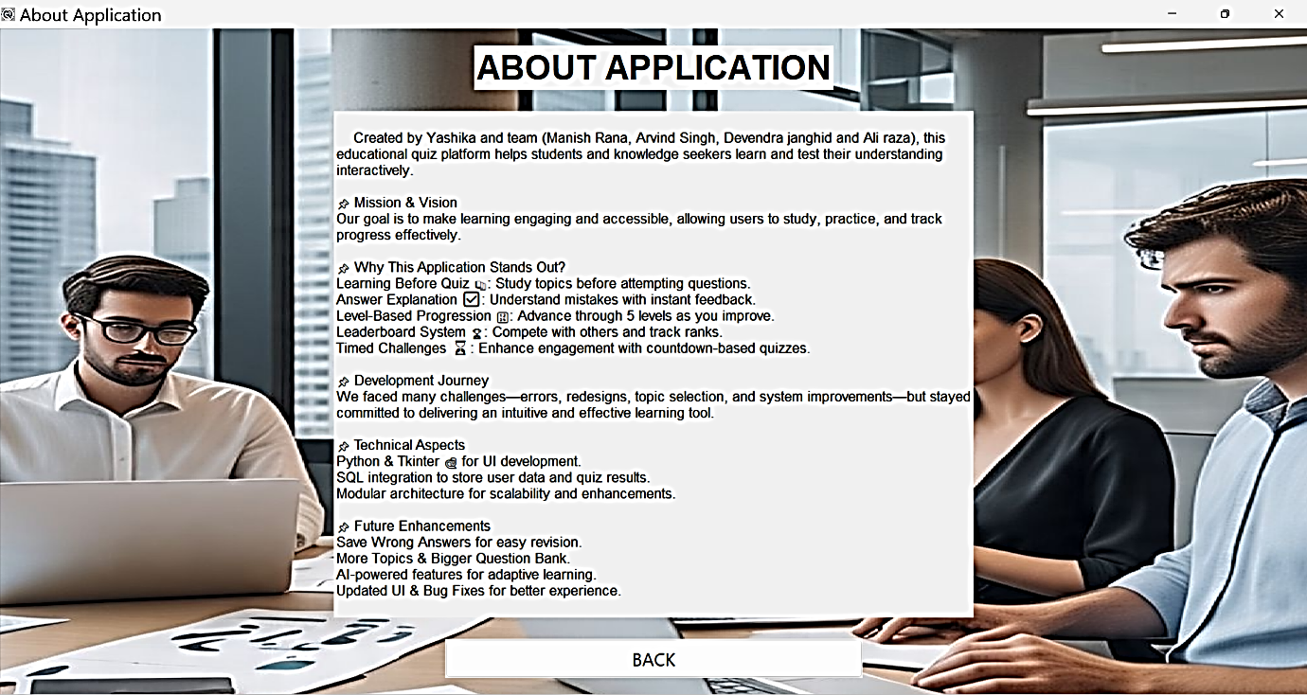

**Conclusion**

The “ QUIZ APPLICATION ” has been developed to solve

the problems in Education Department when it is done manually. At the same time the software meets the objective to maintain database for future interest.

All the information flows and processes of the system were represented in the form of database was designed with the concentration of the users of the software. The tables were normalized to reduce redundancy and inconsistency; all the data are stored in the database in the form of 2-D relational tables.

The software has been developed by keeping in mind the convenience of users. It is developed in such a way such that any user without any detailed knowledge of the system can handle with it. The user interacts with the system through messages displayed at various stages. Any illegal action is promoted by any other message.

**DEVELOPED BY**

**YASHIKA SORANI**

**MANISH RANA**

**DEVENDRA JANGHID**

**ALI RAZA**

**ARVIND SINGH**

**Reference Book:**

1. Python Crash Course: A Hands-On, Project-Based
2. Python Cookbook: Recipes for Mastering Python 3
3. effective python



